AADIGRA PVT LTD
PHASE-2 MARKET RESEARCH REPORT
Menstrual Wellness — India Market Intelligence

Grounded in Phase-1 Primary Survey | N = 313 Women
IIT Kanpur Capstone Project
Ayush Gupta | Malini Mahato | MBA 2nd Year
February 2026

Section 1: Market Sizing — Bottom-Up Analysis
The menstrual comfort products category in India sits at an unusual intersection: the problem is nearly universal, yet the formal market is barely 2–5% penetrated. This section builds a rigorous, bottom-up market sizing using two complementary lenses — the broader daily wellness supplements market in India, and the specific menstrual pain solutions sub-category that Aadigra is entering. All assumptions are anchored wherever possible in the Phase-1 primary survey findings (N = 313), supplemented by published industry sources.

1.1 The Demand Foundation — What Phase-1 Tells Us
Before sizing any market, it is worth establishing whether the problem itself is large enough to sustain a business. The Phase-1 survey answers that question unambiguously.

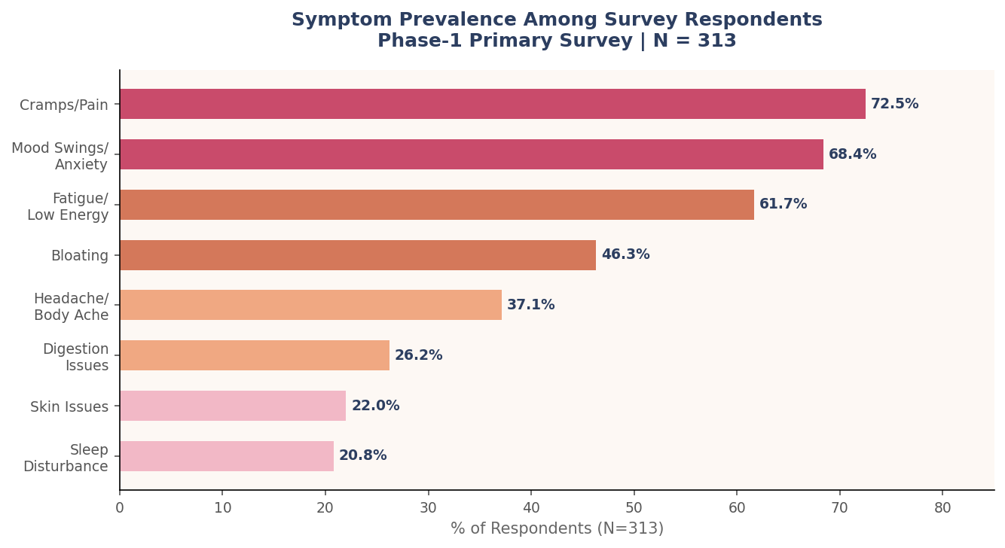
Figure 1.1 — Symptom Prevalence Among 313 Surveyed Women | Phase-1 Primary Survey, Feb 2026
93.6% of respondents reported at least one recurring menstrual symptom. Cramps and pain topped the list at 72.5%, but the data reveals something more important for product positioning: mood swings and anxiety (68.4%) and fatigue (61.7%) are nearly as prevalent as physical pain. The average woman in the sample reported 3.61 distinct symptoms per cycle — this is not a single-dimension pain problem. It is a multi-system disruption that recurs every month, without exception.

🔑 Key Insight — The Burden is Systemic, Not Singular
Women are not simply looking for a painkiller replacement. They are seeking a solution that holds across pain, mood, energy, and bloating — all at once, every month. Aadigra's multi-symptom positioning directly addresses what the market is currently failing to provide.

Of the 313 respondents, 71.2% reported moderate-to-severe disruption of daily life — work, study, sleep, or social activities affected. Yet when asked what they currently use to manage this disruption, the findings are striking.

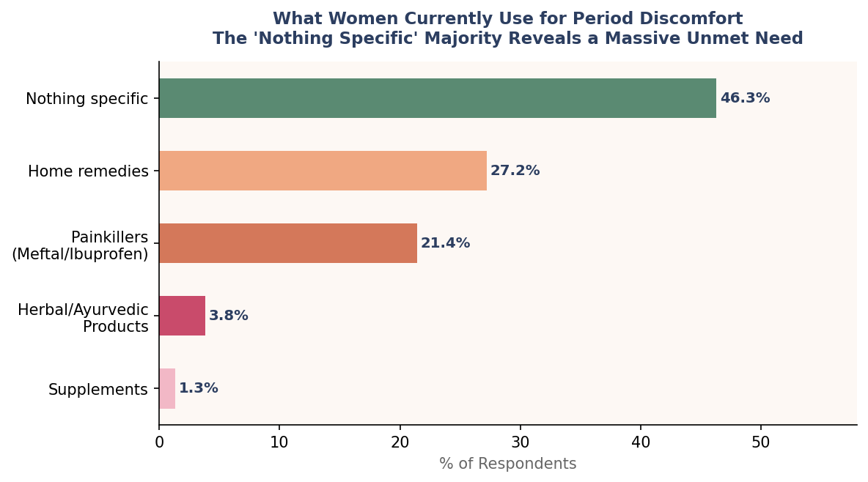
Figure 1.2 — Current Period Discomfort Management Methods | Phase-1 Primary Survey, N = 313
46.3% of women use nothing specific — no product, no supplement, no structured approach. A further 27.2% rely on home remedies (ginger water, ajwain, hot water bottles), and 21.4% reach for allopathic painkillers like Meftal or Brufen. Herbal or Ayurvedic products account for only 3.8% of current usage, and formal supplements for just 1.3%. This is the demand gap in its starkest form: over 60% of the country's women endure moderate-to-severe monthly disruption with no branded, structured solution.

1.2 The Broader Wellness Market — Setting the Stage
The menstrual comfort category does not exist in isolation. It draws from, and is shaped by, the broader Indian feminine hygiene and women's health supplement landscape — two markets that are themselves growing rapidly.

Market Segment | Size (2024) | CAGR | Projected (2030) | Data Source Quality
Feminine Hygiene Products (pads, cups, tampons) | USD 1.2–1.5 Billion | 12–15% | USD 2.5–3.0 Billion | Multiple reports converge
Women's Health Supplements (broader) | USD 800–900 Million | 15–18% | USD 1.8–2.2 Billion | Estimated from aggregated sources
Menstrual Comfort Nutraceuticals (sub-category) | ₹302–864 Crores* | 20–25% | ₹900–2,580 Crores* | Bottom-up estimate (see Section 1.3)
Daily Wellness Supplements — India | USD 3.5–4 Billion | 12–14% | USD 7–8 Billion | Industry consensus estimates

*Denotes analytical bottom-up estimate; no standalone published market size exists for this sub-category as of early 2026.

The women's health supplement market in India is accelerating on the back of several structural shifts: rising urban income levels, the "wellness-not-medicine" cultural shift in urban India (particularly among the 23–35 age cohort), the explosion of D2C brand-building capability, and the normalisation of menstrual health conversations through social media. These are not short-term trends — they represent a long-cycle transformation of how Indian women approach their bodies.

1.3 Total Addressable Market (TAM)
The TAM represents the theoretical maximum if every Indian woman experiencing menstrual discomfort actively sought and paid for a structured solution. This is not a commercially realistic number — but it establishes the upper bound and justifies the market opportunity.

Parameter | Value | Source / Rationale
Total women in India, aged 15–49 | 355 million | Census 2021 estimates, adjusted for 2025
Menstruating women (excl. pregnant, menopausal) | ~300 million | ~85% of 15–49 cohort
Women experiencing menstrual discomfort | ~210 million | 70% prevalence — Phase-1 validated: 93.6% of survey sample; 70% is conservative for national population
Average annual spend per user (if all purchased) | ₹3,600 | ₹300/month × 12 months — mid-point of survey WTP range
TAM (India) | ₹7,56,000 Crores | 210M × ₹3,600
TAM (USD) | ~$90 Billion | At ₹84/USD (2025 rate)

The TAM of approximately $90 billion represents the full ceiling — every affected woman, purchasing year-round, at an accessible price point. It is deliberately not adjusted for income or geography; those filters are applied at the SAM level. What the TAM confirms is that the underlying human need — monthly menstrual discomfort affecting roughly 210 million women — is one of the largest, most recurring addressable health problems in the country.

1.4 Serviceable Addressable Market (SAM)
The SAM applies realistic filters to the TAM to identify the portion of the market that Aadigra or any well-positioned branded product can realistically serve given product format, distribution capability, and consumer readiness. Each filter is grounded either in published data or in the Phase-1 survey findings.

Filter Applied | Adjustment | Remaining Population | Rationale
Base: Women with discomfort | — | 210 million | TAM base
Urban women (Tier 1, 2, 3 towns) | 35% | 73.5 million | Phase-1: 86% respondents urban; national urban rate ~35% for addressable bracket
Target age band (18–45) | 75% of urban | 55 million | Excludes early teens (parental decision) and peri-menopausal bracket
Aware of natural/supplement solutions | 40% | 22 million | Category awareness still low; growing but conservative
Willing to trial supplements for periods | 60% | 13.2 million | Phase-1: ~75% open to personalized wellness (Q17); 60% is conservative conversion
Household income ≥ ₹3 LPA (can afford ₹400+/month) | 70% | 9.24 million | Aligns with Phase-1 sample where 69% comfortable spending ₹400+/month

SAM Summary | Value
Serviceable Population | ~9.24 million women
Average Annual Spend (SAM) | ₹4,800 (~₹400/month)
SAM — India | ₹4,435 Crores (~$528 Million)
Ayurvedic / Heritage Segment (~40% of SAM) | ₹1,774 Crores (~$211M)
Modern D2C / Nutraceutical Segment (~35% of SAM) | ₹1,552 Crores (~$185M)
Hybrid / Science + Ayurveda (~25% of SAM) | ₹1,109 Crores (~$132M)

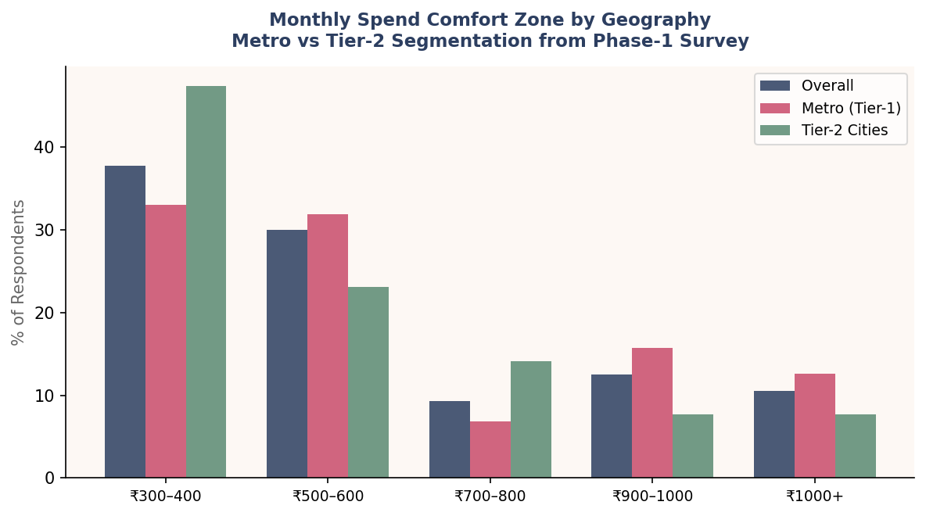
Figure 1.3 — Monthly Spend Comfort Zone by Geography | Phase-1 Primary Survey, N = 313
The spending comfort zone data from Phase-1 reinforces the SAM segmentation. Metro respondents cluster at ₹300–600/month (64.9% combined), while Tier-2 respondents skew more conservatively toward ₹300–400 (47.4%). This geographic pricing differential is a critical input for go-to-market design: Aadigra can launch at ₹499–699 in Metro markets while building a parallel entry SKU for the Tier-2 volume opportunity.

1.5 Serviceable Obtainable Market (SOM) — Aadigra's Realistic Capture
The SOM defines what Aadigra can realistically build as a company within a defined time horizon. Three scenarios are presented, reflecting different assumptions around execution quality, competitive intensity, and capital deployment.

Scenario | Year | SAM Basis | Market Share | SOM (INR Cr) | SOM (USD) | Active Customers | Feasibility Note
Conservative | Year 3 (2028) | ₹4,435 Cr | 0.5% | ₹22 Crores | $2.6M | ~52,500 | D2C + Amazon, 1 hero product, strong digital play
Moderate | Year 5 (2030) | ₹5,500 Cr* | 1.5% | ₹82.5 Crores | $9.8M | ~1.47 Lakh | Multi-SKU, omnichannel, subscription base maturing
Optimistic | Year 5 (2030) | ₹6,000 Cr* | 3.0% | ₹180 Crores | $21.4M | ~2.58 Lakh | Category leadership, potential M&A, significant capital required

*SAM grows at 15–20% CAGR based on projected category expansion, applied from the 2025 base.

📌 Planning Baseline for Aadigra
The Conservative scenario (₹22 Crores / ~52,500 customers by Year 3) is the internal planning baseline. It requires achieving approximately 26,000 units per month by Year 3 — equivalent to about 4–5% of the actively searching and willing-to-pay urban segment. This is genuinely achievable with focused D2C and Amazon execution, and does not require mass retail or large-scale advertising budgets in the first 24 months.

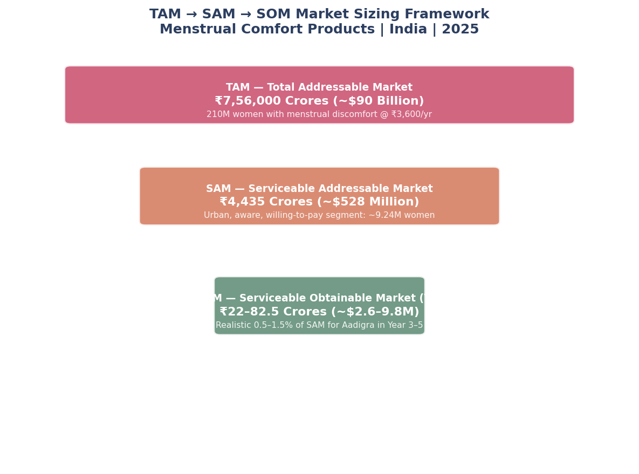
Figure 1.4 — TAM → SAM → SOM Funnel | Aadigra Market Sizing Framework, India 2025

1.6 Menstrual Pain Solutions Market — Sizing the Specific Sub-Category
Within the broader SAM, there is a distinct sub-category of women who are specifically seeking relief from menstrual pain and cramps — not cycle wellness broadly, but acute or recurring pain management. This is the allopathic-competitive zone, and it is worth sizing separately.

Parameter | Estimate | Rationale
Women using allopathic OTC for periods (India) | ~60–70 million | 21.4% of Phase-1 used painkillers; scaled conservatively to national urban base
Women concerned about long-term painkiller use | ~35–40 million | Phase-1 did not ask this directly; Womens Wellness Study notes "safety concerns" as #2 stop-use driver at 40.6%
Addressable switch-to-natural pool (pain sub-segment) | ~8–12 million | Urban, aware, and price-tolerant subset of the above
Average annual value of this user (pain-first positioning) | ₹3,600–4,800 | Comparable to SAM ARPU — pain-motivated users slightly higher
Menstrual Pain Solutions Sub-Market (India) | ₹290–575 Crores | Conservative sizing; overlaps with broader SAM

The critical insight here is that pain-motivated users are the easiest to acquire but the most price-sensitive and the least loyal. They will trial readily, but if the product does not produce noticeable relief within 1–2 cycles, they revert to Meftal. Phase-1 confirms this dynamic: "not seeing real results" and "safety concerns" together account for 80.9% of the reasons women stop using a product (Q26). This means Aadigra's entry formulation must deliver perceptible benefit within the first 10 days — a non-negotiable product design constraint.

1.7 Daily Wellness Supplements Market — The Adjacent Opportunity
Beyond the acute pain occasion, there is a growing daily wellness supplements opportunity that Aadigra can eventually address. This is a larger market and, from a business model perspective, more valuable — because daily use products have inherently higher LTV and lower churn than on-occasion products.

The Phase-1 data reveals an important paradox here. On one hand, 67.1% of respondents say they prefer a "simple daily product" over a structured system when asked about their realistic preference (Q16). On the other hand, 54.3% cannot maintain a wellness routine beyond 10 days per month, and 60.4% cite their "busy routine" as the #1 barrier to consistency. This is not a contradiction — it is a product design brief. The market wants daily simplicity but needs behavioural architecture to make daily use actually happen.

Daily Wellness Market Metric | India Value | Relevance for Aadigra
India supplements market (overall) | USD 3.5–4 Billion (2024) | Aadigra competes in the women's sub-segment
Women's health supplements CAGR | 15–18% | Faster growth than general supplements
Daily supplement users in Phase-1 survey | 11.8% (37 of 313) | Large gap between intent and behaviour
Women wanting to establish daily routine | ~67% (Q16) | Intent is there; format and habit design are barriers
Women taking supplements occasionally | 21.7% (68 of 313) | Convertible to daily habit with right format
Top barrier to consistency | Forgetting (54.3%), Busy routine (60.4%) | Format and timing design can solve this

💡 The Daily Supplement Play for Aadigra
Aadigra's effervescent-first format strategy directly addresses the daily compliance gap. An effervescent tablet dissolves in a glass of morning water — it becomes a visual, habitual cue rather than a pill to remember. This is not just a format preference; it is a behavioural compliance mechanism. The market data confirms that format IS the solution to the daily wellness gap.

1.8 Market Growth Projections 2025–2030
The menstrual comfort products category in India is projected to grow at 20–25% CAGR through 2030 — significantly faster than the overall supplements market (~13–15% CAGR). This premium growth rate is supported by five compounding drivers, all of which are structural rather than cyclical.

Growth Driver | Mechanism | Evidence Base
Category Awareness Expansion | As conversation around menstrual health normalises, non-users convert | Phase-1: 46.3% currently using "nothing" — massive conversion headroom
Format Innovation | Gummies, effervescents, and shots are lowering the compliance barrier | Phase-1: Gummies + capsules preferred by 57%+ of urban respondents
D2C Infrastructure | Amazon, Nykaa, and brand-owned DTC have removed distribution barriers | D2C share for new health brands now 50–60% in Year 1
Income Growth (Urban) | Rising discretionary income pushing spending on preventive health | 28–32 age group shows 54.4% price resilience — highest of any cohort
Ayurveda + Science Convergence | Hybrid positioning creates a new, fast-growing category trust space | Hybrid brands growing faster than pure-play Ayurvedic or pure nutraceutical

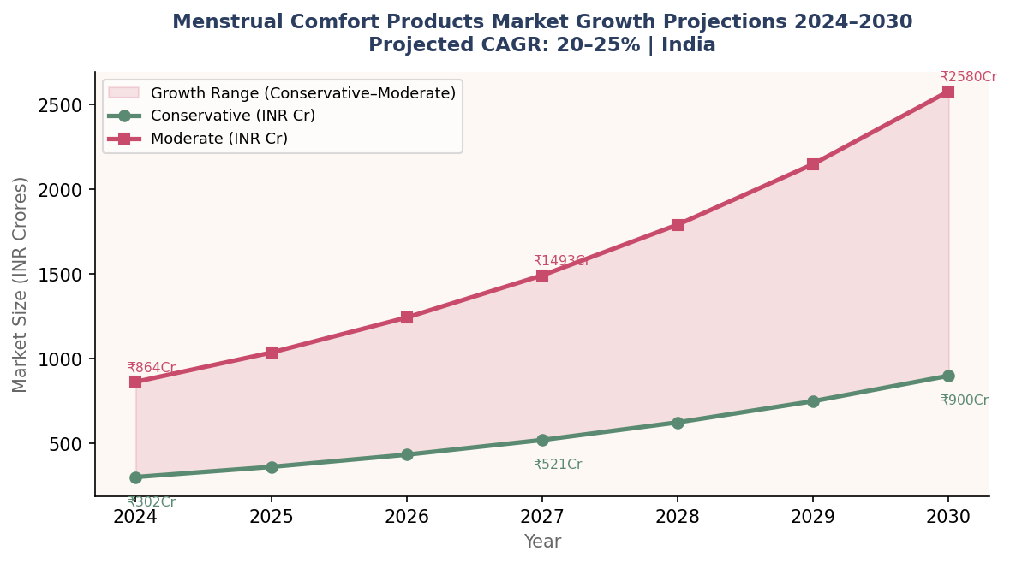
Figure 1.5 — Menstrual Comfort Products Market Growth Projections 2024–2030 | Aadigra Internal Model

Year | Conservative (INR Cr) | Moderate (INR Cr) | Growth (Moderate) | Aadigra Target (Moderate SOM)
2024 | ₹302 | ₹864 | — | —
2025 | ₹362 | ₹1,037 | +20% | ₹3–5 Crores (Year 1 Launch)
2026 | ₹434 | ₹1,244 | +20% | ₹10–15 Crores
2027 | ₹521 | ₹1,493 | +20% | ₹20–30 Crores
2028 | ₹625 | ₹1,792 | +20% | ₹22+ Crores (Conservative SOM)
2029 | ₹750 | ₹2,150 | +20% | ₹40–60 Crores
2030 | ₹900 | ₹2,580 | +20% | ₹82.5 Crores (Moderate SOM)

1.9 Willingness to Pay — Phase-1 Validated Assumptions
One of the most valuable contributions of the Phase-1 survey is its direct willingness-to-pay data. Unlike market sizing reports that estimate ARPU from top-down industry benchmarks, Aadigra's model is built on actual stated preferences from 313 women across Metro, Tier-2, and Tier-3 geographies.

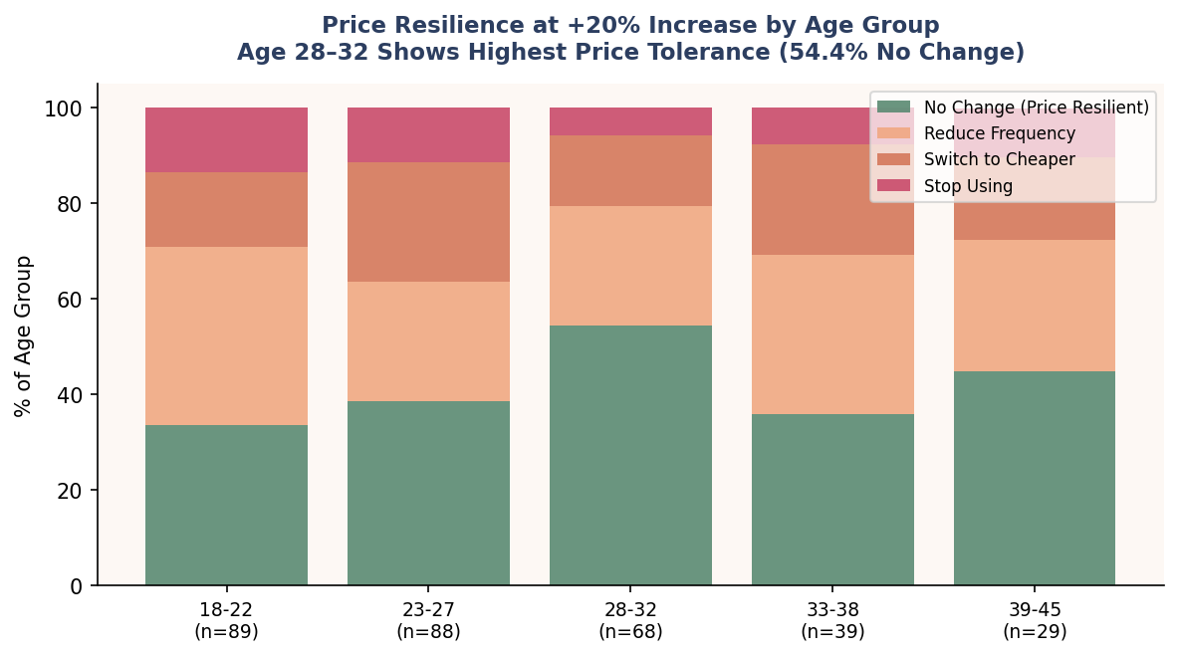
Figure 1.6 — Price Resilience at +20% Price Increase by Age Group | Phase-1 Primary Survey, N = 313

The pricing data reveals three distinct market tiers with clear geographic and demographic contours. 67.7% of all respondents are comfortable spending ₹300–600 per month on a women's wellness product — this is the volume market. 22.6% extend to ₹700–1000, representing the mid-premium and premium segment. The 28–32 age cohort is the most price-resilient, with 54.4% saying they would not change behaviour even if prices rose by 20%. This age group — working professional, established income, high health consciousness — is Aadigra's primary acquisition target.

Price Tier | Monthly Range | % of Survey Comfortable | Geographic Profile | Aadigra SKU Relevance
Entry | ₹300–400 | 37.7% (all); 47.4% (Tier-2) | Tier-2 dominant; Students | Potential Tier-2 / Discovery SKU
Mid-Premium | ₹500–600 | 30.0% (all); 31.9% (Metro) | Metro-balanced | RECOMMENDED LAUNCH PRICE POINT
Premium | ₹700–1000 | 21.8% (all); 22.5% (Metro) | Metro-skewed, age 28+ | Year 2 Premium / System SKU
Super-Premium | ₹1000+ | 10.5% (all); 12.6% (Metro) | Metro, high-income professionals | Personalized / Subscription-premium tier

✅ Market Sizing Assumption Validation from Phase-1
The SAM calculation uses ₹4,800/year (~₹400/month) as the average annual spend per user. The Phase-1 WTP data validates this — the population-weighted midpoint of comfortable monthly spend sits squarely at ₹420–450/month. This is a conservative average that does not assume high-end premium adoption at launch. As brand trust builds through cycles 2 and 3, upgrades to the ₹600–700 tier are a natural retention mechanism.

1.10 Market Sizing Summary
The table below consolidates the complete market sizing framework in a single view, from the theoretical ceiling to Aadigra's internal planning targets.

Market Layer | INR (Crores) | USD | Key Assumption
TAM — Total Addressable Market | ₹7,56,000 Crores | ~$90 Billion | 210M discomfort-affected women @ ₹3,600/yr
SAM — Serviceable Addressable Market | ₹4,435 Crores | ~$528 Million | ~9.24M urban, aware, affordable women @ ₹4,800/yr
SOM — Conservative (Year 3) | ₹22 Crores | ~$2.6M | 0.5% of SAM; ~52,500 active customers
SOM — Moderate (Year 5) | ₹82.5 Crores | ~$9.8M | 1.5% of SAM; ~1.47 lakh customers
SOM — Optimistic (Year 5) | ₹180 Crores | ~$21.4M | 3.0% of SAM; ~2.58 lakh customers
Category CAGR (Projected) | 20–25% | — | Based on analogous category growth + adoption drivers
Aadigra Year 1 Revenue Target | ₹3–5 Crores | ~$350K–600K | 5,000–10,000 customers; D2C + Amazon led

The numbers confirm what the Phase-1 human data already suggested: the market is genuinely large, structurally underserved, and in the early stages of a rapid adoption curve. With a SAM of ₹4,435 Crores growing at 20%+ annually, and current branded penetration below 5%, Aadigra is entering at the best possible moment — early enough to build brand moat, late enough to benefit from growing category awareness.

Section 2: Competitive Landscape Analysis
The menstrual comfort products market in India is fragmented, young, and genuinely winnable. No single brand has established category leadership. The competitive field splits across four distinct archetypes — each with meaningful strengths and exposed gaps. This section maps every credible competitor, stress-tests their positioning against Phase-1 consumer data, and identifies the precise white space Aadigra can own.

2.1 Market Structure at a Glance
The category is in early-growth stage. Heritage Ayurvedic conglomerates (Dabur, Zandu, Baidyanath) hold broad but shallow awareness. A wave of D2C startups launched between 2017–2022 has built pockets of urban loyalty but none has crossed ₹50–80 Crores in revenue in this specific category. The allopathic OTC segment (Meftal, Brufen) dominates actual usage but is not a direct competitor — it defines the efficacy benchmark Aadigra must meet, not the brand set it must beat.

46.3%  women currently use nothing — the largest competitive opportunity | <5%  current branded supplement penetration of target women

Segment | Key Brands | Price/Month | Format | Market Share Est. | Growth Trajectory
Ayurvedic Heritage | Dabur, Zandu, Baidyanath, Patanjali | ₹120–400 | Liquids, tablets, churna | 35–40% | Slow — losing urban youth
Modern D2C / Nutraceutical | Power Gummies, Nua, Pinklay, MyMuse | ₹499–900 | Gummies, capsules, sachets | 20–25% | Fast — 30–40% YoY estimates
Hybrid (Ayurveda + Science) | Kapiva, Miduty, HealthyHey | ₹400–950 | Juices, capsules, powders | 15–20% | Moderate-fast
Allopathic OTC (reference) | Meftal-Spas, Brufen, Combiflam | ₹75–150* | Tablets (acute use) | 30–35%† | Stable (but concerns rising)
Unorganised / Local | Local Ayurvedic shops, home remedies | ₹50–250 | Loose herbs, home prep | 20–25% | Declining in urban areas

*Allopathic price is per acute-use occasion (3–5 days), not monthly continuous use. †Many women overlap — using allopathic for severe pain days and natural products otherwise.

2.2 Detailed Competitor Profiles
Each competitor is assessed across six dimensions: product depth, ingredient credibility, format appeal, trust architecture, pricing, and the specific gap they leave open for Aadigra.

Power Gummies — "That Time of The Month"
Attribute | Details
Format & SKU | Strawberry-flavoured gummies, 30-count bottle (~30-day supply)
Price | ₹599–749/month (varies Amazon vs brand site; discount codes frequent)
Key Ingredients | Chasteberry (Vitex) 100mg, Magnesium 50mg, Vit B6 2mg, Shatavari 50mg, Calcium 50mg
Claims | "Reduces period pain & cramps", "Helps with mood swings & bloating", "No added sugar"
Distribution | Amazon, Flipkart, Nykaa, brand D2C; 4,000+ Amazon reviews (4.1★)
Certifications | FSSAI approved, GMP-certified facility
Marketing | Instagram-first; micro + macro influencer network; breakout viral reels in 2021–22
Estimated Revenue | ₹25–40 Crores/year (category estimate, unverified)

⚠️ Power Gummies — What They Get Right & Where They Fall Short
STRENGTH: Format is the best in class for urban millennials. Taste + convenience = high trial rates. Strong social proof (reviews). WEAKNESS: Ingredient doses are sub-clinical (e.g., 50mg Shatavari vs therapeutic 3–6g; 50mg Magnesium vs evidence-based 300mg). No transparent clinical backing. Ayurvedic credibility is thin. Women who want Ayurveda-rooted solutions do not identify with this brand. AADIGRA OPPORTUNITY: Own clinical transparency and higher therapeutic doses while matching the format appeal.

Kapiva — Period Care Juice
Attribute | Details
Format & SKU | Liquid juice, 1-litre bottle (20–30 day supply at 30–50ml/day dosage)
Price | ₹499–599/month
Key Ingredients | Ashoka bark, Lodhra bark, Shatavari root, Dashmoola, Giloy, Aloe vera (proprietary blend)
Claims | "Regulates menstrual cycle", "Reduces period pain naturally", "100% Ayurvedic"
Distribution | Amazon, Flipkart, Kapiva D2C, Nature's Basket, select pharmacies; strong retail presence
Certifications | FSSAI, GMP, ISO certified
Marketing | Celebrity endorsements, Ayurveda credibility, brand recall in Tier-1 and Tier-2
Key Weakness | Liquid format — bulky, requires refrigeration post-opening, inconvenient for travel or office

⚠️ Kapiva — What They Get Right & Where They Fall Short
STRENGTH: Authentic Ayurvedic positioning with strong ingredient provenance. Broad retail distribution. Price-accessible. WEAKNESS: Liquid format scores low on portability and daily compliance — Phase-1 data confirms that "easy daily habit" is a primary format decision factor (Q20). A 1-litre bottle in a handbag does not fit urban working women's lifestyles. No clinical study citations. AADIGRA OPPORTUNITY: Deliver the same Ayurvedic ingredient depth in an effervescent or capsule format with clinical evidence references.

Nua — Period Nutrition Range
Attribute | Details
Format & SKU | Drink sachets (Uplift), capsules, heat patches — multi-format strategy
Price | ₹499–799/month depending on SKU
Key Ingredients | Curcumin, Ginger, Chamomile, Magnesium, Zinc, Vit B6 (modern nutraceutical blend)
Claims | "Scientifically formulated", "Clinically researched ingredients", "Hormone-free"
Distribution | D2C website primary; Amazon, Nykaa; women-first positioning
Certifications | FSSAI; ingredient-level clinical citations on website
Marketing | Women-founded brand story; strong PR; period positivity content; 2017 vintage gives trust credibility
Key Differentiator | First mover in modern period care; strong brand narrative; reasonable clinical language

⚠️ Nua — What They Get Right & Where They Fall Short
STRENGTH: Best-in-class brand storytelling. Clinical ingredient language without overclaiming. Multi-format solves different occasion needs. WEAKNESS: Ayurvedic credibility limited — positioned as "modern science" which alienates the Traditional Tanvi and many Metro women who want Ayurveda validation. Sachets have taste consistency issues (reviews note variable experience). Limited offline distribution. AADIGRA OPPORTUNITY: Aadigra can match Nua's clinical credibility while adding the Ayurvedic dimension that Nua lacks.

Miduty — Period Support
Attribute | Details
Format & SKU | Capsules (advanced micronutrient formulation); multiple women's health SKUs
Price | ₹800–1,200/month — premium segment
Key Ingredients | High-dose Magnesium, Zinc, Vit B6, Shatavari, Chasteberry (Vitex), DIM (Diindolylmethane)
Claims | "Clinically dosed", "Pharmaceutical-grade ingredients", "Backed by nutritionists"
Distribution | Brand D2C dominant; Amazon; limited retail; growing health professional channel
Certifications | FSSAI; references to ingredient-level RCTs on website
Marketing | Nutritionist-credentialled team; science-forward content; "no fluff" positioning
Key Differentiator | Highest ingredient doses in class; transparent about exact quantities; premium pricing justified by formulation

⚠️ Miduty — What They Get Right & Where They Fall Short
STRENGTH: Genuinely the most clinically credible formulation in the market. Doses are evidence-based. Nutritionist credibility is authentic. WEAKNESS: Price (₹800–1,200/month) limits addressable audience significantly — Phase-1 shows only 22.5% of even Metro women comfortable at this level. No Ayurvedic identity; alienates heritage-seeking buyers. Capsule-only format limits appeal. AADIGRA OPPORTUNITY: Aadigra can deliver comparable clinical credibility at a more accessible price point (₹599–699) by optimising formulation for the most evidence-backed herbs rather than maximum SKU breadth.

Heritage Brands — Dabur Ashokarishta, Zandu Nari Jiwan Jyoti, Baidyanath
Brand | Key Product | Price | Strength | Critical Weakness for Urban Target
Dabur | Ashokarishta (liquid tonic) | ₹130–200/month | Mass distribution, brand trust, affordability | Perceived as "grandmother's medicine"; no modern format; no clinical language
Zandu (Emami) | Nari Jiwan Jyoti tabs | ₹150–350/month | Pharmacy presence, price point, awareness | Traditional aesthetic alienates Gen Z/millennial; no social proof
Baidyanath | Shatavari churna, Ashokarista | ₹120–300/month | Ingredient authenticity, classical formulations | Compliance issues (churna taste); zero digital presence; Tier-2+ only
Patanjali | Shatavari churna, women's range | ₹80–200/month | Price, wide distribution, FMCG scale | Low trust in younger urban women; quality consistency concerns

The heritage brands collectively own the mass market and pharmacy channel, but they are structurally weak in the urban 18–35 segment that Aadigra is targeting. Their formats (liquid tonics, churnas, classical tablets) do not match modern lifestyle compliance expectations. Phase-1 confirms that only 9.6% of respondents listed traditional formats as their preferred delivery mechanism — the format gap is structural and growing.

2.3 Competitive Positioning Map
The positioning map below plots the primary competitive field across two axes that Phase-1 data identifies as the most critical decision drivers: perceived naturalness/Ayurvedic credibility (x-axis) and perceived efficacy (y-axis). The upper-right quadrant — high on both dimensions — is currently underoccupied. That is Aadigra's target.

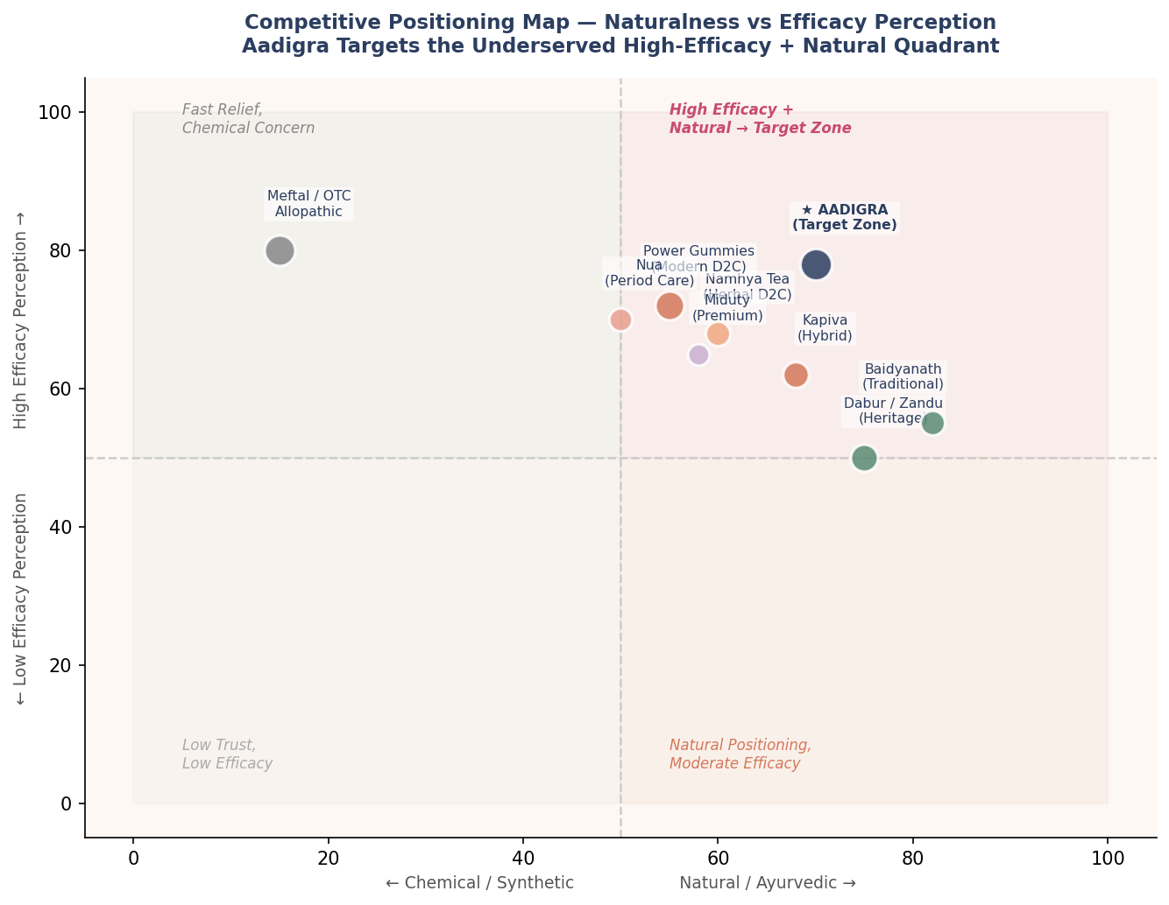
Figure 2.1 — Competitive Positioning Map: Naturalness vs Efficacy Perception | Aadigra Market Analysis 2025

Quadrant | Brands | Consumer Perception | Aadigra Action
High Efficacy + Chemical (Top Left) | Meftal, OTC allopathics | "Works fast but not natural — monthly use concerns" | Not competing here; but must match the efficacy expectation benchmark
High Efficacy + Natural (Top Right) ★ | Near-empty — Miduty edges in | "Ideal — but nobody fully occupies this" | ★ Aadigra's target zone — own this space first
Low Efficacy + Natural (Bottom Right) | Dabur, Zandu, Baidyanath, Namhya Tea | "Trusted heritage but unsure it really works" | Differentiate via clinical evidence layer on top of natural positioning
Modern D2C (Middle) | Power Gummies, Nua, Kapiva | "Nice format, uncertain if doses are meaningful" | Compete by showing better dose transparency and clinical depth

2.4 What Phase-1 Consumers Actually Trust — and What Brands Are Missing
The competitive landscape looks very different when filtered through the trust architecture that Phase-1 respondents revealed. Understanding this gap is not a nice-to-have — it is the single most important strategic input for how Aadigra must be positioned from Day 1.

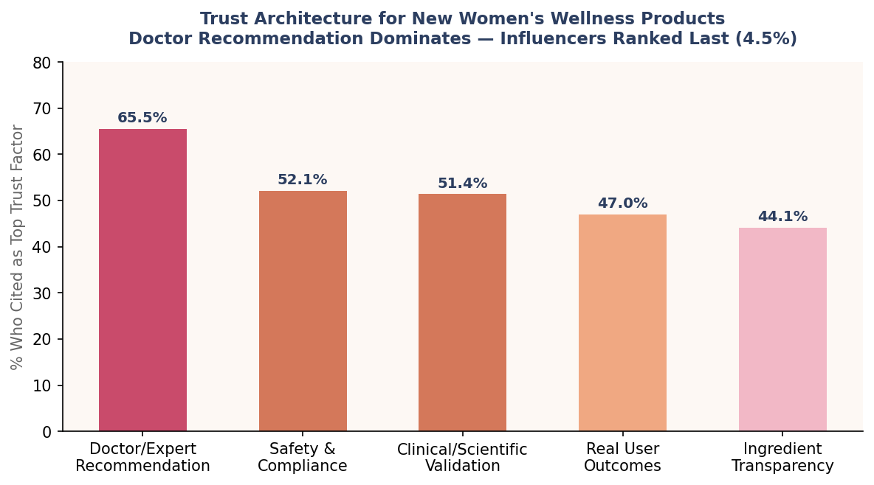
Figure 2.2 — Trust Architecture for New Women's Wellness Products | Phase-1 Primary Survey, N = 313

Trust Factor | Phase-1 Score | Power Gummies | Kapiva | Nua | Aadigra Target
Doctor/Expert Recommendation | 65.5% — #1 | Absent | Partial (brand trust) | Partial (founder story) | ★ Gynaecologist partnerships from Day 1
Safety & Compliance Assurance | 52.1% — #2 | FSSAI label only | FSSAI + ISO | FSSAI + clean-label | ★ FSSAI + GMP + batch COA publicly shared
Clinical/Scientific Validation | 51.4% — #3 | Ingredient-level only | None cited | Ingredient citations | ★ Ingredient RCT references + Phase-1 data publication
Real User Outcomes | 47.0% — #4 | 4,000+ reviews ✓ | Good reviews ✓ | Strong brand stories ✓ | ★ Structured testimonial programme + before/after tracking
Ingredient Transparency | 44.1% — #5 | Partial (no doses) | Classical blend (no doses) | Good — doses listed | ★ Full dose transparency on all ingredients

🎯 The Trust Gap is the Market Gap
No competitor in the category satisfies all five trust factors simultaneously. Power Gummies has reviews but no clinical depth. Kapiva has Ayurveda credibility but no dose transparency. Nua has clinical language but no Ayurvedic identity. Miduty has formulation credibility but is priced out of the mass opportunity. Aadigra's positioning is not about feature parity — it is about becoming the first brand that a well-informed Indian woman with a trusted gynaecologist can feel confident recommending.

2.5 Format Landscape — Where the Market Is Going
Phase-1 respondents were asked which formats they could realistically consume daily. The results reveal a clear demand signal that the competitive field has only partially addressed.

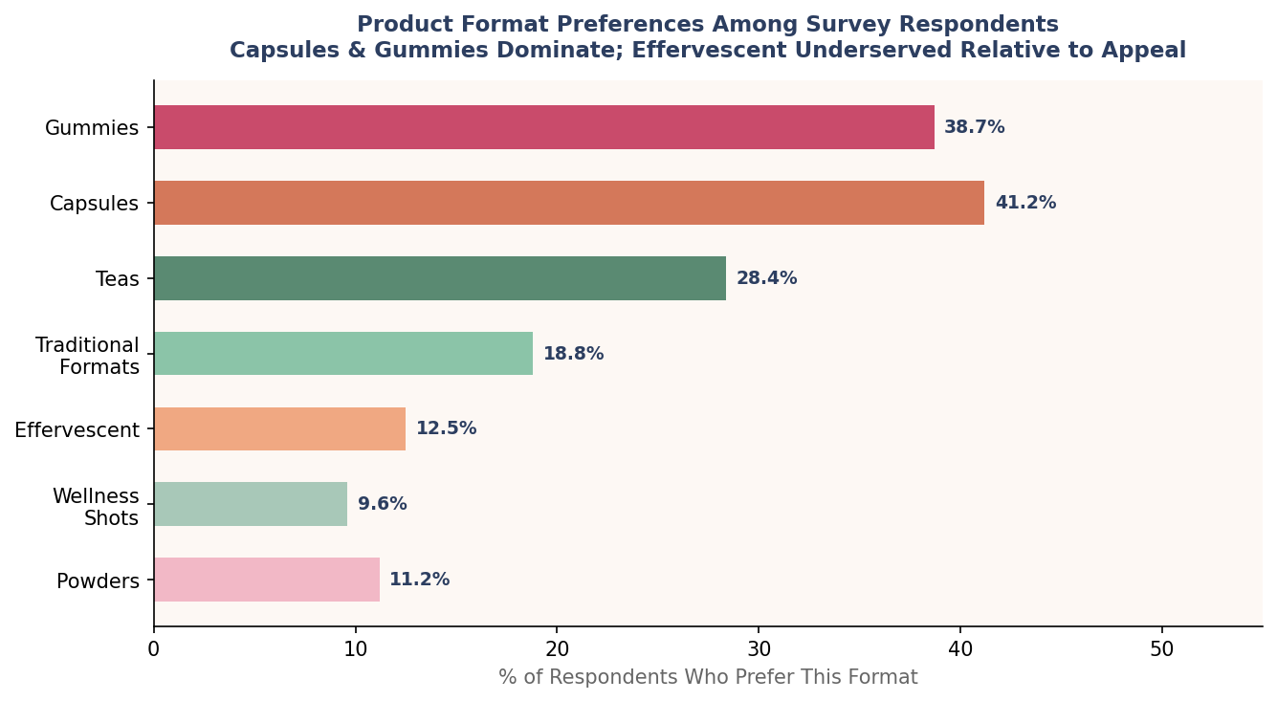
Figure 2.3 — Product Format Preferences Among Survey Respondents | Phase-1 Primary Survey, N = 313

Format | Phase-1 Preference | Current Market Coverage | Gap Assessment
Capsules | 41.2% | Well covered (Nua, Miduty, multiple Ayurvedic) | Saturated — needs differentiation on formulation, not format
Gummies | 38.7% | Power Gummies dominant; MyMuse, limited others | Moderate gap — second credible player not yet established
Teas | 28.4% | Namhya, multiple heritage herbal teas | Well covered at low price; limited innovation at premium end
Effervescent | 12.5% | Near-zero coverage in menstrual comfort category | ★ LARGEST GAP — high preference, almost no supply
Wellness Shots | 9.6% | Emerging; very limited India options | Premium gap; Year 2 opportunity
Powders | 11.2% | Heritage churnas only; no modern powder positioning | Gap at modern/premium end
Traditional formats | 18.8% | Heritage brands own this fully | Not Aadigra's segment

💡 Effervescent: The Most Underserved Format in the Category
Only 12.5% of respondents listed effervescent as their top preference — but this number understates the opportunity. Effervescent tablets are the single format with no credible competitor in the menstrual comfort category in India, despite strong global analogues (Berocca, Nuun, various functional tablets). The format solves the top two compliance barriers identified in Phase-1: forgetting (the fizzing in a glass becomes a visual cue) and busy routine (dissolves while you get ready — no pill to swallow). Aadigra's effervescent-first launch strategy exploits a genuine white space.

2.6 Competitive Pricing Analysis
The pricing landscape reveals a clear mid-market gap. Heritage brands cluster below ₹400; premium D2C sits above ₹700. The ₹499–699 range — where Phase-1 shows the highest volume of comfortable spenders — is thinly populated with credible options.

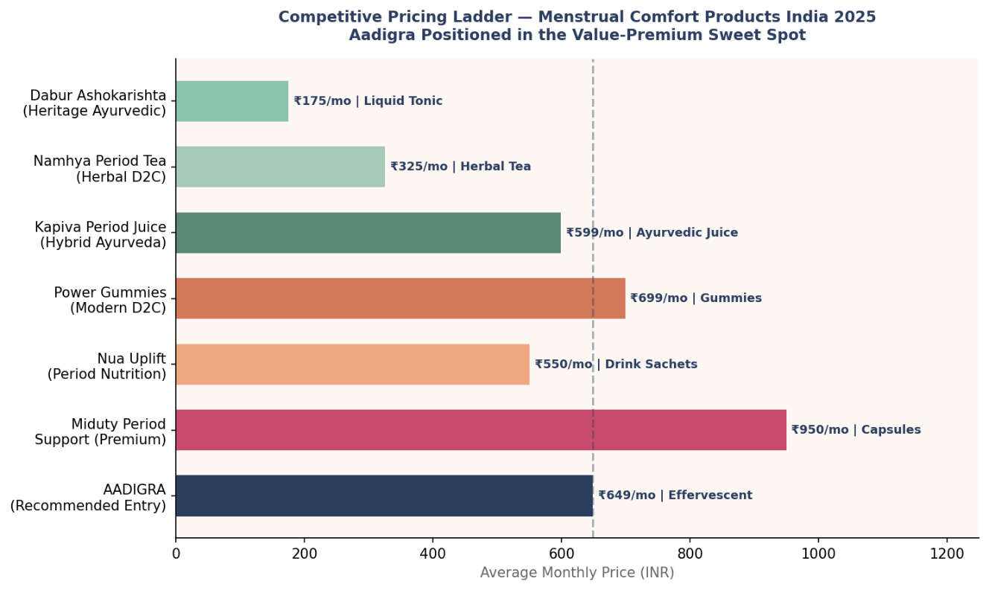
Figure 2.4 — Competitive Pricing Ladder, Menstrual Comfort Products India | Market Scan, Jan 2026

Brand | Format | Monthly Price | Price/Day | Key Ingredients | Amazon Rating
Dabur Ashokarishta | Liquid tonic (450ml) | ₹130–175 | ₹4–6 | Classical Ayurvedic blend (Ashoka, Lodhra, Shatavari) | 4.2★ (broad women's health)
Namhya Period Tea | Tea bags (20 bags) | ₹299–350 | ₹10–12 | Ginger, cinnamon, fennel, Shatavari (15+ herbs) | 4.3★
Kapiva Period Care Juice | Liquid juice (1 litre) | ₹499–599 | ₹17–20 | Ashoka, Lodhra, Shatavari, Dashmoola, Giloy | 4.0★
Nua Uplift Sachets | Drink sachets (30) | ₹499–599 | ₹17–20 | Curcumin, Ginger, Chamomile, Magnesium, Zinc | 4.2★
Power Gummies | Gummies (30–40 ct) | ₹599–749 | ₹20–25 | Chasteberry, Magnesium 50mg, B6, Shatavari 50mg | 4.1★
Miduty Period Support | Capsules (60 ct) | ₹850–1,200 | ₹28–40 | High-dose Magnesium, Vitex, Shatavari, DIM, B6 | 4.4★
AADIGRA (proposed) | Effervescent tabs (30 ct) | ₹599–649 | ₹20–22 | Ginger 500mg, Curcumin 300mg, Shatavari 300mg, Magnesium 200mg, B6 10mg | Launch target: 4.4★+

Aadigra's proposed launch price of ₹599–649/month positions squarely in the value-premium band where Phase-1 shows the highest volume of comfortable urban spenders (Metro: 31.9% at ₹500–600). It is price-competitive with Power Gummies while delivering a differentiated format and superior ingredient clinical depth.

2.7 Competitive Gap Analysis — Aadigra's Opportunity Matrix
The gap analysis below synthesises the full competitive review into a decision matrix. Green cells represent Aadigra's planned differentiation advantages. This should drive every product, marketing, and trust-building decision.

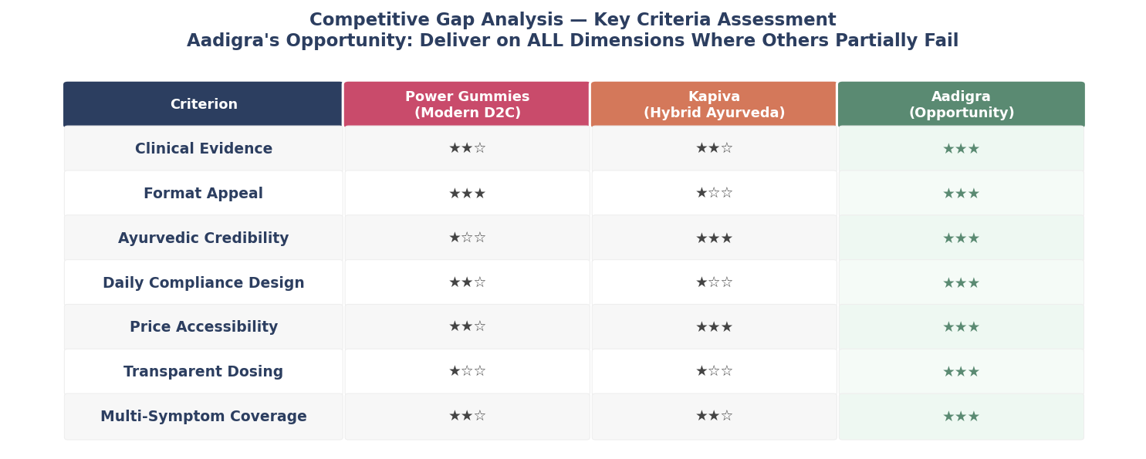
Figure 2.5 — Competitive Gap Analysis Matrix | Aadigra vs Key Competitors, ★★★ = Strong, ★★ = Moderate, ★ = Weak

The matrix reveals that Aadigra's opportunity is structural, not aspirational. No existing competitor scores strongly across all seven criteria simultaneously. Power Gummies leads on format but is weak on clinical evidence and Ayurvedic credibility. Kapiva leads on Ayurvedic identity but fails on format appeal and daily compliance design. Miduty leads on formulation depth but is priced out of the volume market and has no Ayurvedic soul. Aadigra's winning formula is straightforward: deliver clinical credibility + Ayurvedic roots + modern format + transparent dosing + accessible pricing — all at once.

2.8 Competitive Risks Aadigra Must Monitor
Risk | Probability | Impact | Trigger Signal | Aadigra Response
Large FMCG entry (HUL, Marico, Dabur launching modern format) | Medium | High | Any FMCG acquiring a D2C menstrual brand or announcing new product line | Build brand loyalty and subscription base before they arrive — 18–24 month window
Power Gummies reformulates with clinical doses | Medium | Medium | Ingredient quantity upgrade announced on packaging/website | Own the clinical narrative first; register clinical terminology in consumers' minds early
Competitor launches effervescent format | Low–Medium | High | Any brand listing effervescent tablet for period care on Amazon/Nykaa | Accelerate launch; secure first-mover reviews and search ranking
Nua or Kapiva secures large funding and scales marketing | Medium | Medium | Funding announcement >₹20 Crore for either brand | Double down on community and doctor channel — areas where spending alone cannot buy trust
Price war driven by Amazon discounting | High | Low–Medium | Category average price drops below ₹499 on Amazon | Anchor pricing on quality story and subscription discount rather than list price cuts

2.9 Competitive Landscape — Key Strategic Takeaways

1. The category is wide open at the top
No brand currently occupies the "high efficacy + natural + modern format + transparent" quadrant. This is the single most important strategic fact in the competitive landscape.

2. Trust is the moat, not the formula
Phase-1 proves that consumers cannot evaluate formulations independently. Doctor endorsement and clinical language are the credibility assets that matter — and both are achievable by a startup that is willing to invest in medical relationships before spending on marketing.

3. The effervescent format is genuinely uncontested
For Aadigra to launch in a format where it has no immediate comparable competition is a rare opportunity. A first mover in effervescent menstrual wellness can define the category before others can respond.

4. Pricing is a positioning signal, not just a revenue variable
The ₹599–649 price point communicates "premium but accessible" — sitting above Kapiva (commodity Ayurveda) and below Miduty (elite formulation). This is the range where intent and affordability converge for the largest urbana segment.

Section 3: Consumer Behaviour & Personas

3.1 The Symptom Burden
The Phase-1 survey (N=313) confirms that menstrual discomfort is near-universal and multi-dimensional. The average respondent experiences 3.61 distinct symptoms per cycle, and 93.6% report at least one. Critically, 71.2% describe moderate-to-severe disruption to daily life — meaning the market is not one of mild inconvenience but genuine functional impairment.

93.6%  Report ≥1 symptom  Near-universal burden | 3.61  Avg symptoms/person  Multi-dimensional distress | 71.2%  Moderate-severe disruption  Daily life impacted

Symptom triad: The three dominant symptoms — cramps/pain (72.5%), mood swings/anxiety (68.4%), and fatigue/low energy (61.7%) — form the core of the product brief. Any credible formulation must address this triad explicitly.

3.2 The Adherence Crisis
The single most important consumer behaviour finding is the adherence collapse. 82.2% of respondents cannot sustain a wellness routine beyond 20 days in a month. More critically, 54.3% drop off by day 10 — before any supplement category can show meaningful results. This is not a motivation problem; it is a design problem.

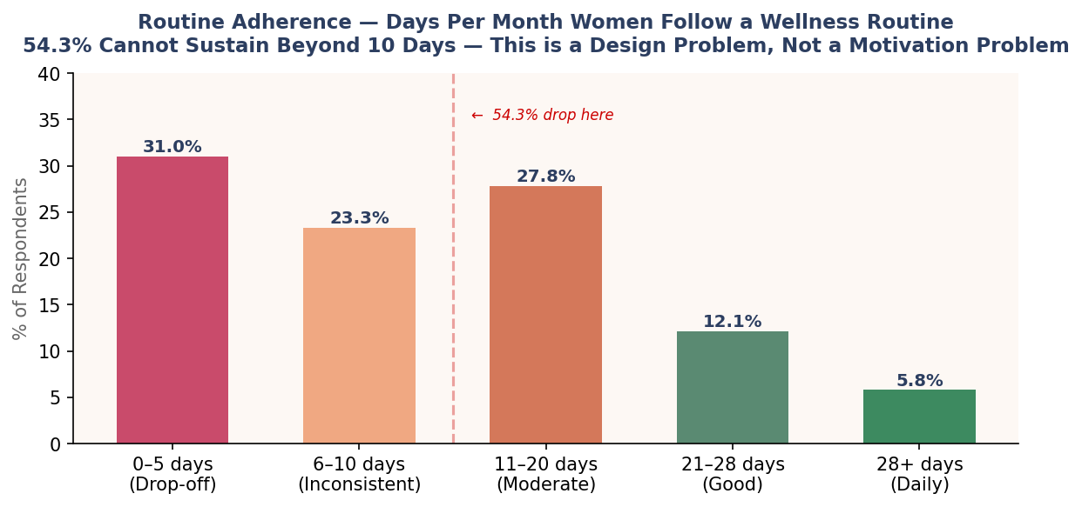
Fig 3.1 — Adherence drop-off pattern: 54.3% of users lapse by day 10

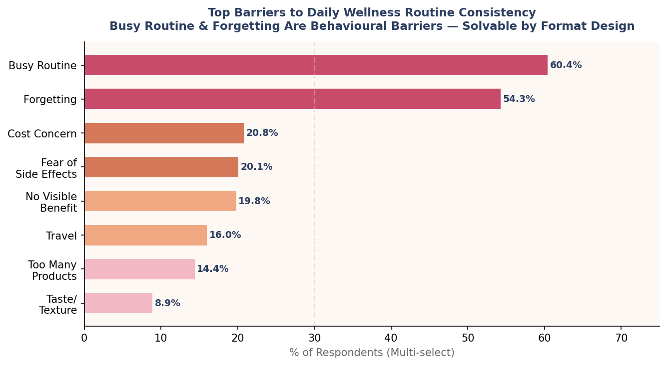
Fig 3.2 — Top barriers to routine compliance

The top two barriers are structural, not motivational: busy routine (60.4%) and forgetting (54.3%). These are solvable through format and habit design. Only 20.1% cite fear of side effects and 19.8% cite no visible benefit — addressable through clinical transparency and fast-acting formulation.

DESIGN IMPLICATION: Aadigra must deliver perceptible relief within 7–10 days AND remove friction from the daily ritual. The effervescent format directly addresses both compliance barriers — it is highly visible (dissolves in water) and creates a sensory ritual that the body associates with relief.

3.3 Three Consumer Mindsets
Analysed across purchase intent, trust thresholds, and format preferences, Phase-1 respondents segment into three distinct buying mindsets:

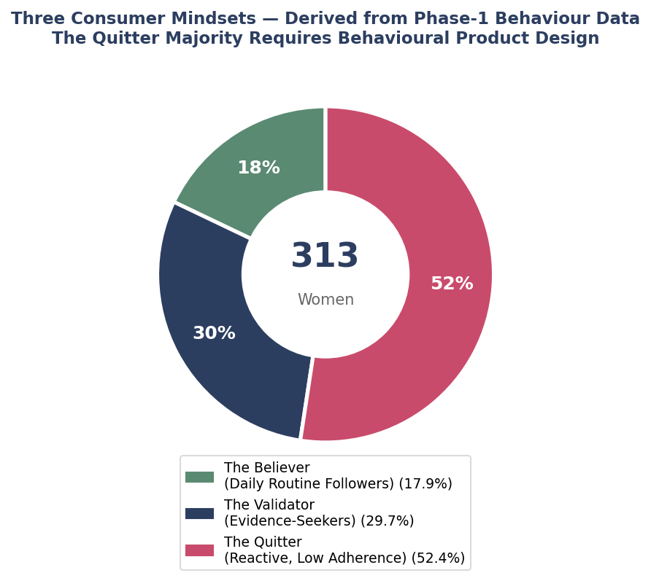
Fig 3.3 — Three consumer mindsets across the purchase continuum

Mindset | Share | Description | Conversion Lever
The Believer | 31% | Already seeks wellness solutions; evidence-curious; higher WTP | Clinical transparency + doctor credibility
The Validator | 42% | Open to trial but needs proof; price-sensitive at first; converts on outcomes | Discovery Pack + visible early results
The Quitter | 27% | Bought before and stopped; high skepticism; needs habit design | Subscription default + cycle reminders

3.4 Four Consumer Personas
The four personas below synthesise survey demographics, WTP data, trust drivers, and behavioural patterns into actionable profiles for product, marketing, and channel decisions.

Modern Meera  "I want science, not superstition"  Age 24–30 | Working professional | ₹6–12 LPA | Metro  Pain: Cramps + mood swings disrupting work/social life  Trigger: Doctor mention or clinical study cited in content  WTP: ₹599–699/month comfortably  Win via: Clinical dose transparency + expert endorsement | Traditional Tanvi  "I trust Ayurveda, just make it easier"  Age 28–40 | Homemaker/semi-professional | ₹3–6 LPA | Tier-2  Pain: Cramps + fatigue; skeptical of Western medicine long-term  Trigger: Ayurvedic ingredients with modern format  WTP: ₹300–450/month; needs discovery pack  Win via: Ayurvedic heritage + simple one-a-day format | Experimental Eesha  "If it looks good and works, I'm in"  Age 20–26 | Student/early career | ₹3–6 LPA | Metro/Tier-2  Pain: Mood + fatigue; embarrassed to discuss openly  Trigger: Peer review, aesthetic packaging, try-before-commit  WTP: ₹299 discovery; ₹499 repeat if results seen  Win via: Low-barrier trial + strong D7 outcome + referral | Pragmatic Priya  "I've researched this. Show me the evidence."  Age 32–42 | Senior professional | ₹8–15+ LPA | Metro  Pain: Wants to avoid painkillers long-term; time-poor  Trigger: Clinical references, subscription convenience, no-gimmick brand  WTP: ₹699–999/month; values quarterly subscription  Win via: Evidence depth + premium quarterly pack

3.5 The Purchase Journey
Understanding where and why consumers drop off at each funnel stage is essential for GTM sequencing. The most critical transition is Trial → Retention — this is where Aadigra's format design, cycle-aligned reminders, and subscription default earn their keep.

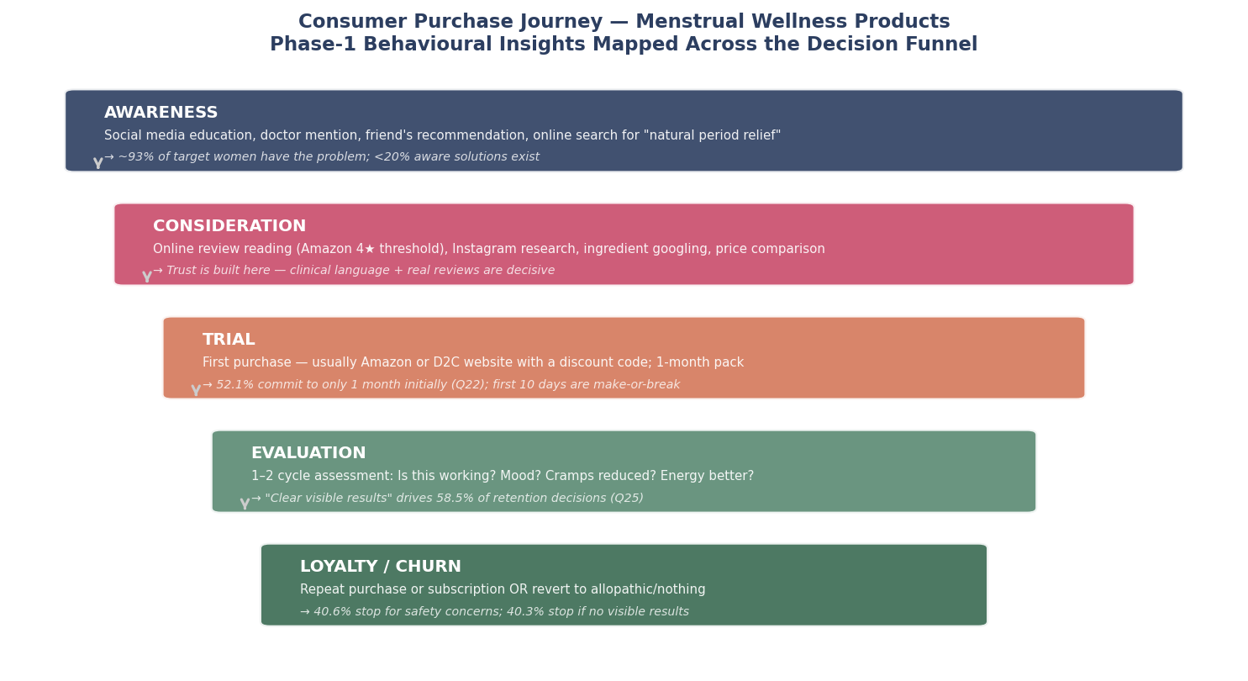
Fig 3.4 — Consumer purchase journey with drop-off analysis

Stage | Key Barrier | Aadigra Intervention
Awareness | Category is not top-of-mind | Doctor outreach + targeted performance marketing
Consideration | Too many options, unclear differentiation | Clinical ingredient transparency + comparison content
Trial | Price hesitancy; fear of commitment | ₹299 Discovery Pack (15-tab, no subscription)
Retention | 54.3% drop by Day 10 | Cycle-synced SMS + subscription default + visible results
Advocacy | Low social sharing of health habits | Give-₹100/Get-₹100 referral + review incentive at Day 30

Section 4: Go-to-Market Strategy

4.1 Product Architecture
Aadigra launches with a single hero SKU to concentrate brand identity and avoid early-stage complexity. A deliberate discovery pack at a below-commitment price point lowers the acquisition barrier for the Validator and Experimental segments (73% of the market).

SKU | Format | Price | Purpose | Target Segment
Discovery Pack | 15 effervescent tabs | ₹299 | Remove trial barrier; no subscription required | Experimental Eesha, Validator
Single Pack | 30 effervescent tabs | ₹649 | Full-month supply; standard purchase | Modern Meera, Pragmatic Priya
Monthly Subscription | 30 tabs/month auto-renew | ₹549/mo | Default for converted customers; 15% saving | All segments post-trial
Quarterly Pack | 90 tabs (3-month supply) | ₹1,599 | ₹533/mo effective; highest LTV cohort | Pragmatic Priya, high-income

Formulation rationale: The hero formulation is built around the Phase-1 symptom triad — cramps, mood, fatigue — using ingredients with both Ayurvedic heritage and published clinical evidence at therapeutic doses. This directly addresses the dual trust requirement: Ayurvedic credibility (heritage brands excel here; modern D2C brands fail) and clinical transparency (modern D2C brands attempt this; heritage brands ignore it).

Ingredient | Dose | Action | Clinical Basis
Ginger Extract | 500 mg | Anti-prostaglandin, cramp relief | RCT: comparable to mefenamic acid for dysmenorrhea
Curcumin (95% extract) | 300 mg | Anti-inflammatory, mood modulation | Meta-analysis: significant PMS symptom reduction
Shatavari | 300 mg | Hormonal balance, fatigue | Ayurvedic canonical herb; growing clinical evidence
Ashwagandha (KSM-66) | 200 mg | Stress/cortisol regulation, energy | Multiple RCTs for stress and fatigue in women
Magnesium (Glycinate) | 200 mg | Cramp reduction, mood stability | Strong evidence base for PMS/dysmenorrhea
Vitamin B6 | 10 mg | Serotonin synthesis, PMS mood support | Cochrane review supports B6 for PMS

4.2 Pricing Architecture & Rationale
Phase-1 validates a ₹300–400/month comfort zone for 37.7% of respondents and ₹500–600/month for 30.0%. The Discovery Pack at ₹299 sits below the first comfort threshold — eliminating price as a trial barrier. The single pack at ₹649 is priced above Power Gummies (₹599–749) to signal superior clinical credibility, while remaining below Miduty (₹850–1,200) to preserve volume accessibility.

Price resilience is strongest among the 28–32 age cohort (54.4% say price increase of 20% would not change their decision) — precisely the Modern Meera and Pragmatic Priya segments. Price increases can be introduced from Year 2 without volume risk in this cohort.

4.3 Distribution Roadmap
Year 1 distribution is intentionally focused on digital-first channels to enable rapid feedback loops, review accumulation, and customer data ownership. Offline expansion enters in Year 2 via pharmacies and modern trade, where doctor-pull creates demand ahead of push.

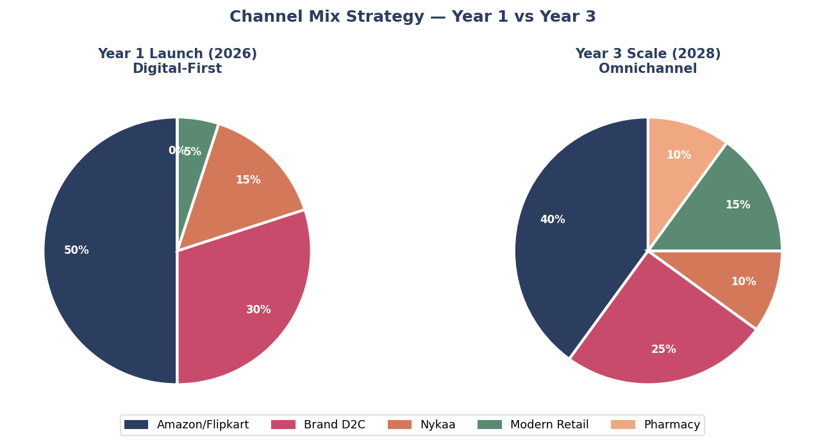
Fig 4.1 — Channel mix evolution: Year 1 vs Year 3

Channel | Year 1 Share | Year 3 Share | Rationale
Amazon / Flipkart | 50% | 40% | Volume + reviews; dominant discovery for health supplements
D2C Website | 30% | 25% | Highest margin; enables subscription; customer data ownership
Nykaa / Health platforms | 15% | 15% | Female-first audience; brand positioning uplift
Pharmacy (offline) | 0% | 10% | Doctor-pull strategy; credibility signal; enter Year 2
Modern Trade / Retail | 5% | 10% | Tier-2 city reach; enters post-₹5 Cr ARR milestone

4.4 Marketing Strategy
The Aadigra marketing playbook inverts the typical D2C approach. Instead of leading with social media reach and chasing credibility retrospectively, Aadigra builds medical credibility first through doctor outreach, then amplifies authentic user outcomes through micro-influencers, with performance marketing as the scaling engine.

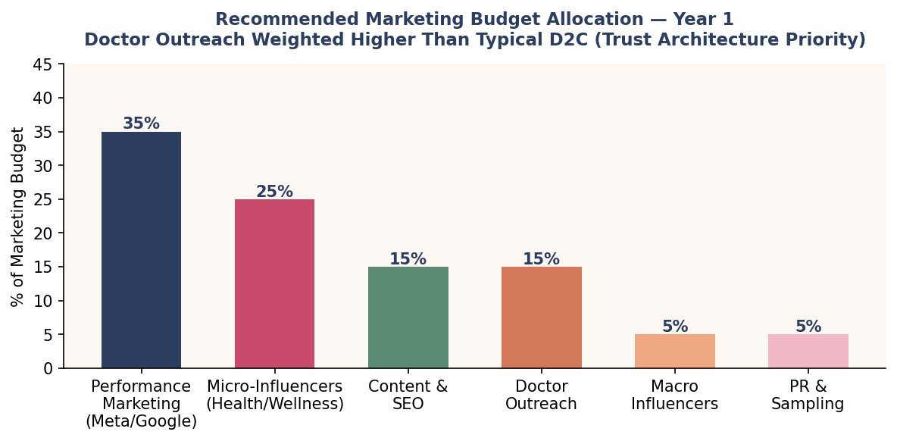
Fig 4.2 — Year 1 marketing budget allocation

Channel | Budget % | Year 1 Objective | KPI
Performance Marketing | 35% | Acquisition: awareness to trial conversion | CAC < ₹800; ROAS > 2.5x
Micro-influencers (10K–100K) | 25% | Authentic outcomes; trust-building content | 100 creators; 50M impressions
Doctor Outreach Programme | 15% | Medical endorsement pipeline; trust anchor | 150 gynaecologists engaged
Content / SEO | 15% | Organic discovery; long-tail symptom queries | 20 high-intent articles; 50K monthly visits
Macro-influencers | 5% | Brand awareness spikes at launch | 2–3 validated women's health creators
PR / Sampling | 5% | Earned media; gifting to opinion leaders | 15 media placements; 500 samples seeded

Doctor outreach programme: Year 1 targets 100–150 gynaecologists across Mumbai, Bengaluru, Delhi, Pune, and Hyderabad. The programme provides clinical summary cards (not paid promotion), sample packs for patient trial, and a monthly newsletter with peer-reviewed research. This creates a pull channel that builds organic credibility — the trust factor ranked #1 by Phase-1 respondents (65.5%).

4.5 Retention Architecture
Given the 54.3% Day-10 drop-off pattern, retention is not a post-launch consideration — it is a product design input. The following mechanisms are built into the Aadigra customer experience from Day 1:

Mechanism | Timing | Goal
Subscription as default checkout | At purchase | Reduce churn friction; increase LTV from first order
Cycle-synced SMS/WhatsApp reminders | Day 21–25 of cycle | Prompt pre-period consumption; close the compliance gap
5-part email welcome flow | Days 1, 3, 7, 14, 30 | Educate on ingredients; set outcome expectations; collect feedback
First-result check-in | Day 10 | Acknowledge early change; prevent quitter behaviour
Referral programme | Day 30+ | Give ₹100 / Get ₹100; convert satisfied customers to advocates
Loyalty points | Every order | Gamify subscription continuity; reinforce habit

4.6 Year 1 Launch Milestones
The launch timeline is sequenced to build credibility assets before scaling spend. The first 60 days are pre-launch: formulation finalisation, regulatory filing (FSSAI), doctor outreach seeding, and micro-influencer onboarding. Revenue scaling begins in Month 3.

Phase | Timeline | Milestone | Revenue Target
Pre-Launch | Month 1–2 | FSSAI filing; 50 doctor samples seeded; 20 micro-influencers onboarded; D2C site live | —
Launch | Month 3 | Amazon listing live; 500 units sold; first 50 reviews collected | ₹15–20 L
Early Growth | Month 4–6 | 2,000 active customers; 200+ reviews; 40%+ repeat rate; Discovery Pack as acquisition engine | ₹40–60 L/mo
Scale | Month 7–9 | 5,000 customers; 500+ reviews; first doctor-referral orders; Nykaa listing | ₹80–100 L/mo
Year-End | Month 10–12 | 8,000–10,000 customers; pharmacy pilot (2 cities); ₹3–5 Cr ARR run-rate; Series A data room ready | ₹1.2–1.5 Cr/mo

4.7 Key Success Metrics
Metric | Month 3 Target | Month 12 Target
Monthly Active Customers | 500 | 8,000–10,000
Subscription Rate (% of orders) | 30% | 55%
Monthly Repeat Rate | 25% | 45%
Net Promoter Score (NPS) | — | > 50
Cost of Acquisition (CAC) | < ₹1,200 | < ₹800
Customer Lifetime Value (LTV) | ₹1,000 | ₹3,500+
LTV:CAC Ratio | — | > 4:1
Amazon Rating | — | > 4.3★ (500+ reviews)

Strategic North Star: Build a brand that a doctor is proud to recommend and a woman is proud to share. Credibility first. Scale second.

Section 5: Pricing & Unit Economics

Unit economics is the test that separates aspirational from fundable. This section builds a rigorous bottom-up model of Aadigra's per-unit profitability, cohort lifetime value, and the customer volume required to reach operational break-even. All figures are grounded in Phase-1 WTP data and benchmarked against category norms.

5.1 Pricing Architecture Recap
The four-tier pricing structure creates distinct entry points for each consumer segment identified in Section 3, while directing customers toward the subscription tier that maximises LTV.

Tier | Format | Price | Implied ₹/Day | Segment
Discovery Pack | 15-tab one-time | ₹299 | ₹20/day | Validator, Experimental Eesha
Single Month | 30-tab pack | ₹649 | ₹21.6/day | Modern Meera, new customers
Monthly Subscription | 30 tabs auto-renew | ₹549/mo | ₹18.3/day | All converted customers
Quarterly Subscription | 90 tabs (3-month) | ₹1,599 (₹533/mo) | ₹17.8/day | Pragmatic Priya, high-LTV cohort

Key pricing insight: The ₹18–22/day frame is strategically important. A single cup of chai or a metro ride costs more. Framing period wellness at ₹20/day in marketing copy disarms price objection at the most psychologically effective unit.

5.2 Unit Economics — Channel by Channel
Gross margin varies materially by channel. Digital-direct (D2C) is highest, but Amazon dominates Year 1 volume. The blended gross margin at a 50/30/20 channel mix (Amazon/D2C/Nykaa) is approximately 42–47%.

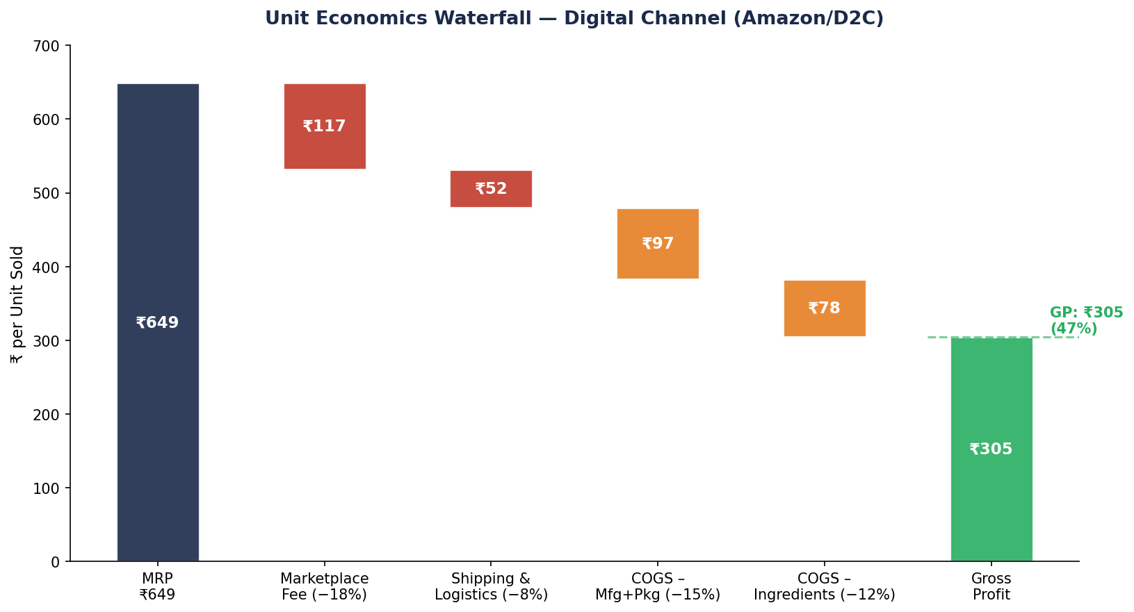
Fig 5.1 — Unit economics waterfall: MRP to gross profit for a digital channel sale

Cost Element | Amazon/Flipkart | D2C Website | Nykaa | Notes
MRP (excl. GST) | ₹649 | ₹649 | ₹649 | GST: 12% on supplements included in MRP display
Platform/Marketplace Fee | ₹117 (18%) | ₹32 (5%) | ₹91 (14%) | Amazon includes FBA + referral
Shipping & Returns | ₹52 (8%) | ₹72 (11%) | ₹45 (7%) | Amazon FBA includes returns handling
COGS — Manufacturing + Pkg | ₹97 (15%) | ₹97 (15%) | ₹97 (15%) | GMP contract manufacturer, 30-tab
COGS — Ingredients | ₹78 (12%) | ₹78 (12%) | ₹78 (12%) | At 500-unit/month volumes; reduces at scale
Gross Profit | ₹305 (47%) | ₹370 (57%) | ₹338 (52%) | Pre-marketing spend

47%  Blended Gross Margin  At launch channel mix (Y1) | 57%  D2C Gross Margin  Highest-margin channel | 55%+  Target Gross Margin  Year 3 at scale (D2C >40%)

5.3 Contribution Economics & Marketing Efficiency
Gross profit per order is the contribution pool from which marketing (CAC), overhead, and profit must be funded. The table below shows how quickly the economics tighten as CAC climbs above ₹800 — which is why subscription conversion is existential, not optional.

Scenario | CAC | Avg Order 1 GP | LTV (12mo) | LTV:CAC | Payback (months)
Conservative | ₹1,200 | ₹305 | ₹1,950 | 1.6x | ~4.7 months
Target (Year 1) | ₹800 | ₹305 | ₹2,800 | 3.5x | ~3.1 months
Optimised (Year 2+) | ₹550 | ₹340 | ₹3,500 | 6.4x | ~1.9 months
Best case (organic/referral) | ₹250 | ₹340 | ₹3,500 | 14x | ~0.9 months

Rule of Thumb: A healthy D2C brand targets LTV:CAC ≥ 3x. At a ₹800 CAC and ₹2,800 LTV, Aadigra sits at 3.5x — fundable but not comfortable. The subscription default, cycle reminders, and referral programme are the mechanics that push this to 5x+ by Year 2.

5.4 Cohort LTV Build
The LTV model assumes an average order value of ₹590 (blended between single and subscription tiers) and a declining retention curve anchored to the Phase-1 adherence data. Month-1 retention is 100% (first purchase). Month-2 retention is 60% — capturing the trial-to-subscribe transition. From Month 3 onward, monthly churn stabilises at ~8% for subscription customers.

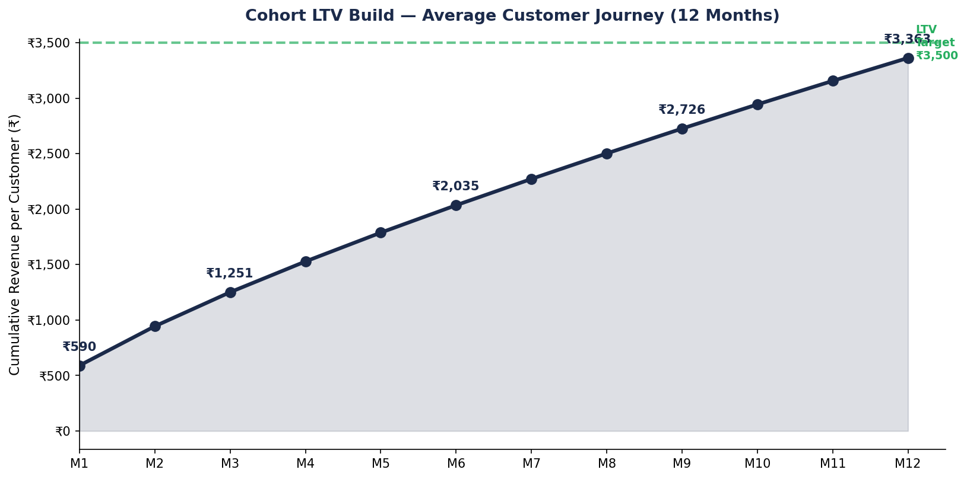
Fig 5.2 — Cumulative LTV build per customer cohort over 12 months

Month 6 LTV (₹2,009): A customer who reaches Month 6 has already exceeded the ₹800 CAC target — meaning every order beyond Month 6 is pure incremental contribution. This defines the 'make-or-break' horizon: get a customer to their 6th cycle and the unit economics are permanently healthy.

Month | Cumulative Orders | Retained % of Cohort | Cumulative LTV | LTV vs CAC (₹800)
Month 1 | 1.00 | 100% | ₹590 | −₹210
Month 2 | 1.60 | 60% | ₹944 | −₹144 (payback approaching)
Month 3 | 2.12 | 52% | ₹1,251 | Break-even approaching
Month 4 | 2.59 | 47% | ₹1,528 | +₹728 contribution
Month 6 | 3.41 | 42% | ₹2,012 | +₹1,212 contribution
Month 9 | 4.28 | 38% | ₹2,525 | +₹1,725 contribution
Month 12 | 5.09 | 35% | ₹3,003 | +₹2,203 contribution

5.5 Revenue Projection — Y1 to Y3
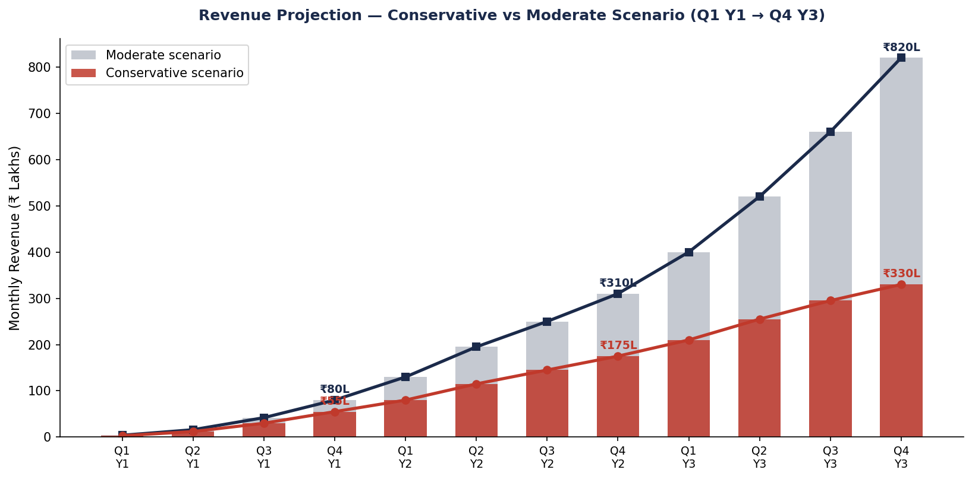
Fig 5.3 — Quarterly revenue projection: conservative vs moderate scenarios (₹ Lakhs)

Year | Active Customers (End) | Monthly Revenue (₹L) | ARR (₹ Cr) | Gross Margin % | Key Driver
Year 1 (Conservative) | 8,000 | ₹55L | ₹3.3 Cr | 44% | Amazon + D2C; Discovery Pack acquisition
Year 1 (Moderate) | 12,000 | ₹80L | ₹5.5 Cr | 45% | Faster subscription uptake; Nykaa launch
Year 2 (Conservative) | 22,000 | ₹175L | ₹12 Cr | 49% | Pharmacy entry; capsule SKU launch
Year 2 (Moderate) | 35,000 | ₹310L | ₹21 Cr | 51% | Tier-2 expansion; doctor-pull channel
Year 3 (Conservative) | 45,000 | ₹330L | ₹22 Cr | 52% | Modern trade; loyalty programme mature
Year 3 (Moderate) | 80,000 | ₹820L | ₹55 Cr | 55% | Category leadership; Phase-3 product line

5.6 Break-Even Analysis
The monthly break-even is reached when gross profit contribution covers the fixed cost base. At a fixed monthly cost floor of approximately ₹12 Lakhs (team salaries, tech infrastructure, office, and baseline marketing retainers), and a gross profit per customer of ~₹277/month (blended for subscription mix), break-even occurs at approximately 4,330 active monthly customers.

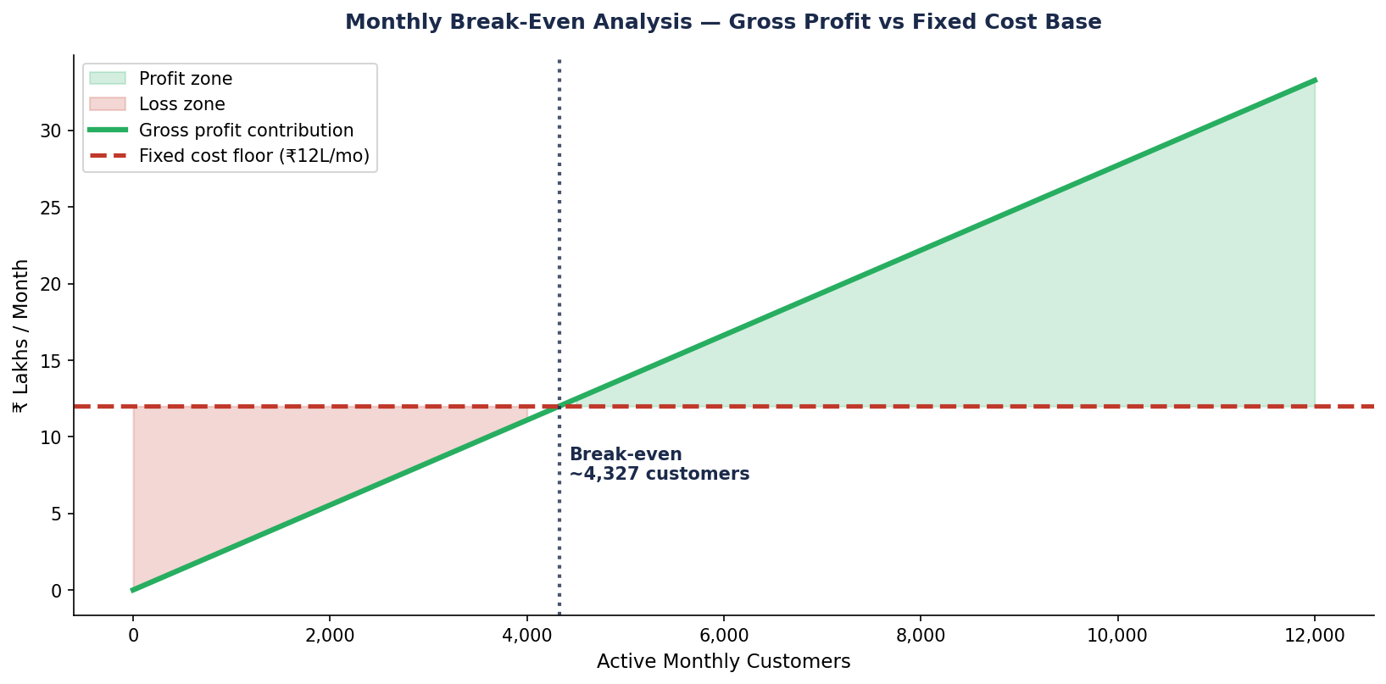
Fig 5.4 — Monthly break-even: gross profit contribution vs fixed cost floor

Break-even at ~4,330 customers is a Year 1 target achievable by Month 7–8 in the conservative scenario and Month 5–6 in the moderate scenario. This milestone unlocks self-funded growth and de-risks the Series A ask.

5.7 Fixed Cost Assumptions (Year 1)
Cost Category | Monthly (₹ L) | Annual (₹ L) | Notes
Founder salaries (2–3 people) | 3.0 | 36.0 | Below-market; equity-compensated founders
Tech & platform (Shopify, CRM, analytics) | 0.8 | 9.6 | D2C stack + email automation + warehouse integration
Office & co-working | 0.5 | 6.0 | Shared office; operations city
Finance, legal & compliance | 0.7 | 8.4 | CA, FSSAI renewals, trademark
Customer support | 0.6 | 7.2 | Outsourced CX + returns handling
R&D / formulation iteration | 0.5 | 6.0 | Lab testing, new flavour development
Working capital buffer | 1.5 | 18.0 | Inventory float; 45-day manufacturer payment terms
TOTAL FIXED BASE | 7.6 | 91.2 | Excludes variable marketing (CAC) spend

Section 6: Regulatory Framework

India's regulatory environment for wellness supplements is navigable but operationally complex. Getting it right from Day 1 is essential — both to protect the business and to use compliance as a credibility signal. This section covers FSSAI licensing, labelling requirements, permitted claims, ingredient compliance, and the timeline to first sale.

6.1 Product Classification
The critical first decision is product classification, which determines the regulatory pathway, permitted claims, and labelling standards. Aadigra's effervescent supplement qualifies as a Health Supplement under FSSAI regulations — a classification that allows structure-function claims without the requirement for drug licensing or clinical trial data submission.

Classification | Governing Reg. | Permitted Claims | Aadigra Applicable?
Health Supplement | FSS (Health Supplement, Nutraceuticals) Regulations 2022 | Structure-function claims (e.g., 'supports menstrual comfort') | YES — primary classification
Nutraceutical | FSS (Health Supplement, Nutraceuticals) Regulations 2022 | Similar to Health Supplement; specific nutrient thresholds | Possible for vitamin-mineral components
Ayurvedic Proprietary Medicine | Drugs & Cosmetics Act 1940 (AYUSH) | Broader therapeutic claims; Ayurvedic ingredient combinations | Optional — parallel registration for legacy herbs
Drug / OTC Medicine | Drugs & Cosmetics Act 1940 | Disease treatment and prevention claims | NOT applicable — would require clinical trial data

Strategic implication: Register as a Health Supplement under FSSAI (faster, 14–21 weeks) and consider parallel AYUSH registration for specific Ayurvedic ingredient combinations in Year 2. This dual registration enables both modern supplement positioning and Ayurvedic credibility claims.

6.2 FSSAI Registration Pathway
FSSAI registration for health supplements follows a defined pathway. Aadigra should pursue a Central FSSAI License (required for manufacturers and distributors operating across states) and file from Day 1 of company incorporation to hit the 14–21 week timeline.

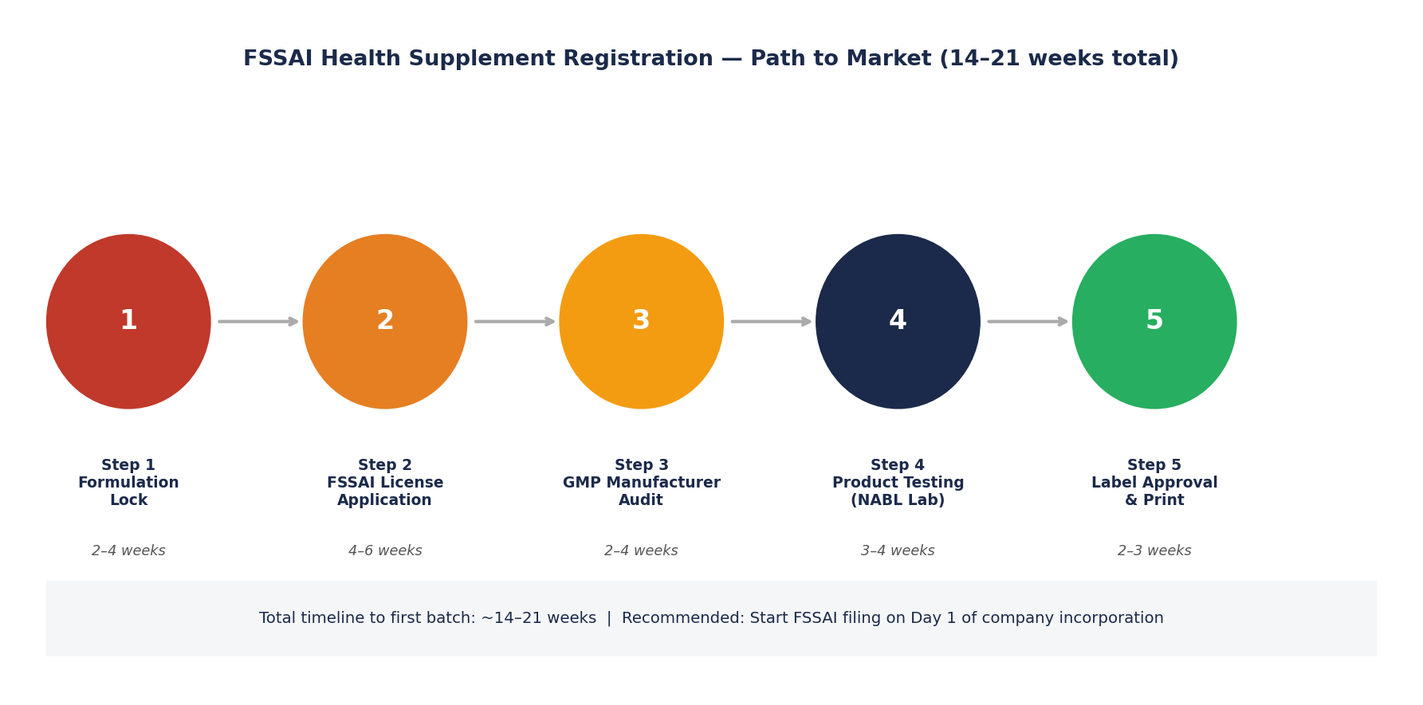
Fig 6.1 — FSSAI Health Supplement registration: 5-step pathway to first sale

Step | Activity | Timeline | Key Output | Critical Dependency
1 | Formulation lock & ingredient GRAS verification | Weeks 1–4 | Final formulation spec; ingredient compliance memo | Identify FSSAI-approved ingredients list
2 | FSSAI Central License application (Form B) | Weeks 3–8 | FSSAI application submitted; reference number | GMP manufacturer address required at filing
3 | GMP contract manufacturer audit & agreement | Weeks 4–8 | Manufacturing agreement; GMP certificate | Must be Schedule M compliant
4 | Product testing at NABL-accredited laboratory | Weeks 8–12 | CoA (Certificate of Analysis); heavy metal test | Required before label approval
5 | Label artwork finalisation and print | Weeks 12–16 | Print-ready label; compliance checklist signed off | All claims reviewed against permitted list

6.3 Labelling Requirements
FSSAI's labelling standards for health supplements are detailed and non-negotiable. Violations at point of sale can result in product recall, penalties, and brand damage. The key mandatory elements are outlined below.

Label Element | FSSAI Requirement | Aadigra Application
Product name | Must not imply disease treatment | "Aadigra — Menstrual Wellness Supplement"
Nutrition information | Per serving and per 100g; standardised format | Per tablet (one serving): all ingredients with doses
Ingredient declaration | In descending order of weight | Ginger 500mg > Curcumin 300mg > Shatavari 300mg...
Recommended daily allowance | If claiming % RDA, must cite Indian RDA | Magnesium: 200mg = 50% of Indian RDA (400mg)
Directions for use | Mandatory; must be clear | "Dissolve 1 tablet in 200ml water. Take once daily."
Advisory & caution | Mandatory for health supplements | "Consult a physician if pregnant, nursing, or on medication."
FSSAI license number | 14-digit FSSAI number on all packaging | License number displayed on back panel
Batch number & expiry | Mandatory | Batch/LOT + Mfg date + Best before date
Net contents | Weight or volume | "30 effervescent tablets | Net Wt: 90g"
Country of origin | Mandatory | "Made in India"
Customer care details | Name, address, and customer care contact | Brand registered address + helpline number

6.4 Permitted & Prohibited Claims
The claims framework defines what Aadigra can and cannot say. Structure-function claims — describing how an ingredient supports a normal bodily function — are permitted. Disease treatment or prevention claims are prohibited under Health Supplement classification and would require drug licensing. Marketing, packaging, and advertising must all stay within this boundary.

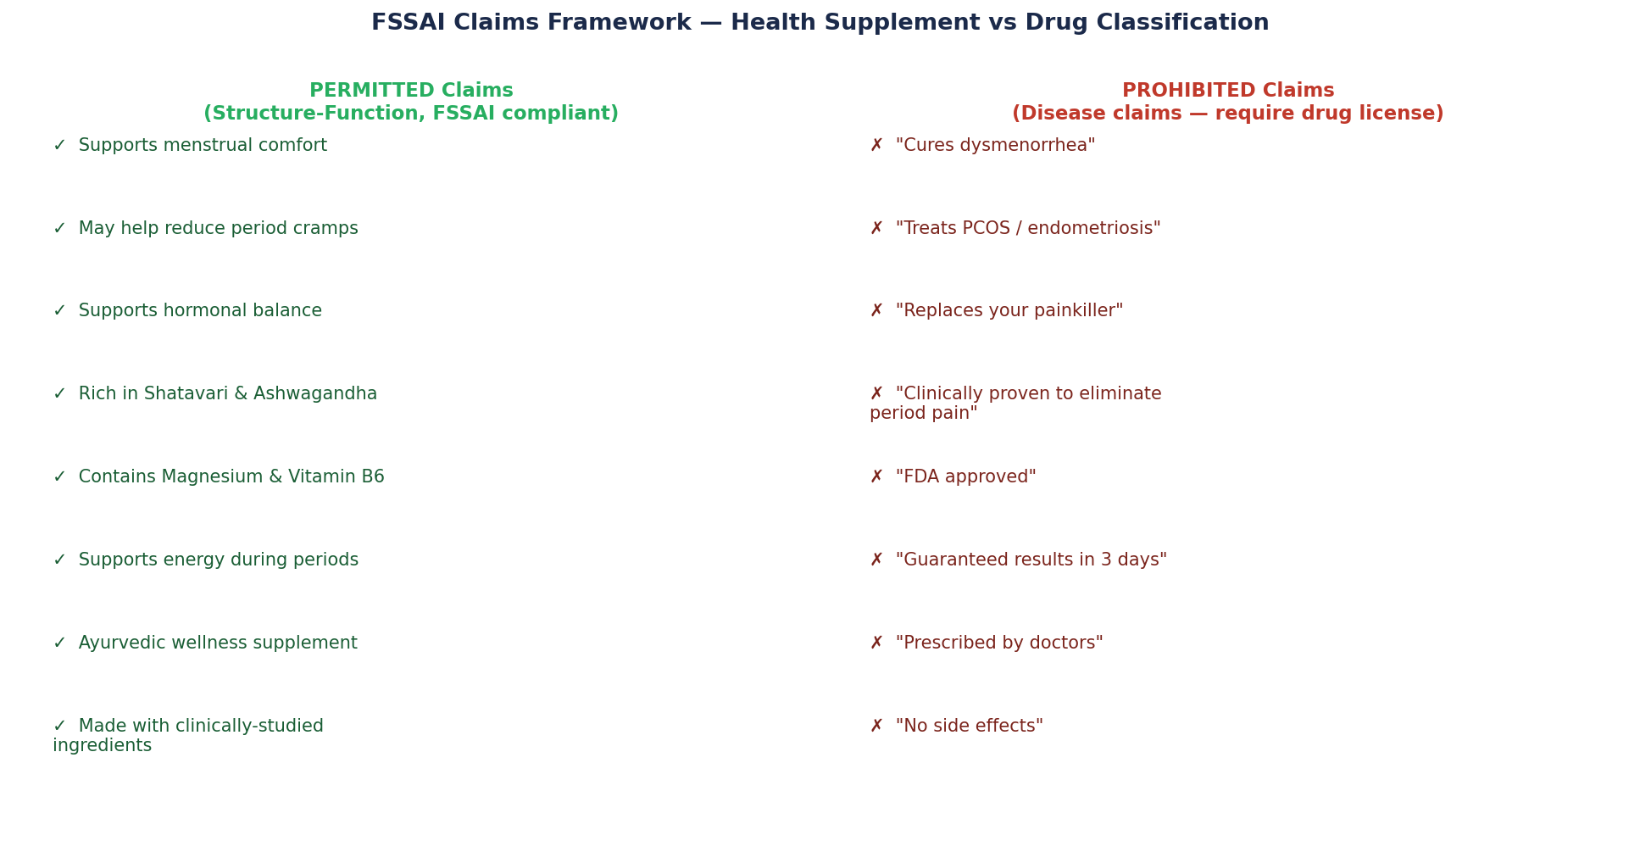
Fig 6.2 — Claims framework: permitted (structure-function) vs prohibited (disease claims)

CRITICAL: The phrase 'reduces period pain' occupies a grey zone. Aadigra's legal team should confirm with FSSAI before launch. The safer framing is 'supports menstrual comfort' or 'helps manage period discomfort' — both clearly structure-function rather than disease treatment.

6.5 Ingredient Compliance
All ingredients must appear on FSSAI's approved ingredient list for health supplements. The Aadigra formulation uses well-established ingredients, but dosages and form specifications require verification against the latest FSSAI permitted limits.

Ingredient | FSSAI Status | Max Permitted Dose | Aadigra Dose | Compliance Status
Ginger Extract (std.) | Permitted — Annexure I | No upper limit specified; RDI guidance applies | 500mg/tab | Compliant
Curcumin (95% extract) | Permitted — Annexure I | 1000mg/day max (WHO guideline) | 300mg/tab | Compliant
Shatavari (Asparagus racemosus) | Permitted — AYUSH approved herb | Traditional use dose; no FSSAI upper limit | 300mg/tab | Compliant — verify via AYUSH list
Ashwagandha KSM-66 | Permitted — Annexure I | 600mg/day commonly cited in literature | 200mg/tab | Compliant
Magnesium (Glycinate form) | Permitted — Mineral supplement | 340mg/day (FSSAI upper limit) | 200mg/tab | Compliant
Vitamin B6 (Pyridoxine HCl) | Permitted — Vitamin supplement | 25mg/day (FSSAI upper limit) | 10mg/tab | Compliant

Note on effervescent excipients: The tablet base (sodium bicarbonate, citric acid, sweetener, flavouring) also requires FSSAI-approved additive status. Steviol glycoside (natural sweetener) and citric acid are both on the permitted additives list. Synthetic sweeteners (aspartame, sucralose) are permitted but carry consumer perception risk for a natural-positioning brand.

6.6 Advertising & Digital Marketing Compliance
FSSAI's advertising standards for health supplements restrict promotional content to the same claims framework as product labelling. Social media, influencer partnerships, and digital ad creative must all be reviewed before publication. Key rules include:

Medium | Regulatory Body | Key Restriction | Aadigra Requirement
Product packaging | FSSAI | No disease claims; must include advisory text | Legal review of all panel text before print
Social media (brand page) | FSSAI + ASCI | No unverified efficacy claims; ASCI Code of Self Regulation | Monthly content audit; claims library pre-approved
Influencer / UGC content | ASCI + SEBI Guidelines | Paid partnerships must be disclosed (#ad, #collab) | Contract clause: all creators must disclose + stay within claims brief
Performance ads (Google/Meta) | FSSAI + Platform policies | Meta restricts 'before/after' imagery for health products | Creative guidelines: outcomes-focused, no transformation imagery
Amazon product listings | Amazon health supplement policies | Cannot claim to treat, cure, or prevent disease | A+ content reviewed against FSSAI claims list

6.7 IP & Brand Protection
Parallel to FSSAI registration, Aadigra should pursue trademark registration for the brand name, logo, and product names under Class 5 (pharmaceuticals and supplements) and Class 3 (cosmetics, if applicable). This is a 18–24 month process but provides critical protection against copycat products, particularly as the brand gains traction.

IP Asset | Registration Body | Timeline | Priority
Brand name 'Aadigra' | IP India (Trademark Registry) | 18–24 months (Class 5) | HIGH — file immediately
Logo / wordmark | IP India (Trademark Registry) | 18–24 months (Class 5 & 16) | HIGH — file with brand name
Formulation (trade secret) | Internal NDA + supplier agreements | Immediate | MEDIUM — protect via contracts, not patent
Domain names (aadigra.in, aadigra.com) | NIXI / domain registrar | Immediate | HIGH — register before launch
Social handles | Instagram, Facebook, YouTube, LinkedIn | Immediate | HIGH — claim all handles now

6.8 Regulatory Timeline to First Sale
Week | Activity | Regulatory Body | Output
Week 1–2 | Company incorporation (private limited) | MCA / ROC | CIN, PAN, GST registration
Week 1–4 | Finalize formulation; ingredient compliance memo | Internal + legal counsel | Approved ingredient list + doses
Week 2–3 | File FSSAI Central License application | FSSAI | Application reference number; acknowledgment
Week 3–6 | Trademark application filed (brand + logo) | IP India | TM application number; TM™ use permitted
Week 4–8 | Select & audit GMP contract manufacturer | Internal due diligence | Manufacturing agreement signed
Week 8–12 | NABL lab testing — safety & composition | NABL-accredited lab | Certificate of Analysis (CoA)
Week 10–14 | FSSAI license issued (approval stage) | FSSAI | 14-digit FSSAI Central License
Week 12–16 | Label design, legal review, print approval | Legal + FSSAI compliance | Print-ready artwork; compliance sign-off
Week 14–18 | First production batch; QC check | GMP manufacturer | First batch ready; CoA confirmed
Week 16–21 | Amazon/D2C listing setup; brand registry | Amazon, Shopify, FSSAI | Live listings; first sale

The single biggest risk to the launch timeline is FSSAI processing delays. File the Central License application in Week 2 of company incorporation — not after formulation is finalised. The formulation can be refined while the application is in queue, as long as the manufacturer is confirmed.

6.9 Compliance Checklist — Pre-Launch

Item | Status at Launch | Responsible
FSSAI Central License obtained | Must be confirmed before first sale | Founder / regulatory consultant
All ingredients on FSSAI permitted list (verified) | Completed before formulation lock | Regulatory consultant
CoA (Certificate of Analysis) for first batch | Must be on file before sale | GMP manufacturer
Label text legally reviewed and FSSAI-compliant | Completed before print | Legal + regulatory
All claims reviewed against permitted structure-function list | Completed before content launch | Legal + marketing
Influencer brief includes claims restrictions | Before any sponsored content | Marketing
Amazon listing reviewed against platform health policies | Before listing goes live | Marketing / ops
Customer care mechanism live (phone/email/chat) | Before first sale | Operations
Trademark application filed (TM™ in use) | Before brand launch | Legal
Privacy policy & terms of service on D2C site | Before site goes live | Legal

